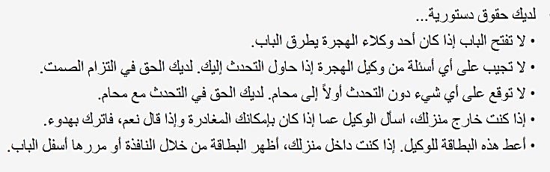
I do not wish to speak with you, answer your questions, or sign or hand you any documents based on my 5th Amendment rights under the United States Constitution.  I do not give you permission to enter my home based on my 4th Amendment rights under the United States Constitution unless you have a warrant to enter, signed by a judge or magistrate with my name on it that you slide under the door.  I do not give you permission to search any of my belongings based on my 4th Amendment rights.  I choose to exercise my constitutional rights.  Know Your Rights Card - Arabic | I do not wish to speak with you, answer your questions, or sign or hand you any documents based on my 5th Amendment rights under the United States Constitution.  I do not give you permission to enter my home based on my 4th Amendment rights under the United States Constitution unless you have a warrant to enter, signed by a judge or magistrate with my name on it that you slide under the door.  I do not give you permission to search any of my belongings based on my 4th Amendment rights.  I choose to exercise my constitutional rights.  Know Your Rights Card - Arabic
I do not wish to speak with you, answer your questions, or sign or hand you any documents based on my 5th Amendment rights under the United States Constitution.  I do not give you permission to enter my home based on my 4th Amendment rights under the United States Constitution unless you have a warrant to enter, signed by a judge or magistrate with my name on it that you slide under the door.  I do not give you permission to search any of my belongings based on my 4th Amendment rights.  I choose to exercise my constitutional rights.  Know Your Rights Card - Arabic | I do not wish to speak with you, answer your questions, or sign or hand you any documents based on my 5th Amendment rights under the United States Constitution.  I do not give you permission to enter my home based on my 4th Amendment rights under the United States Constitution unless you have a warrant to enter, signed by a judge or magistrate with my name on it that you slide under the door.  I do not give you permission to search any of my belongings based on my 4th Amendment rights.  I choose to exercise my constitutional rights.  Know Your Rights Card - Arabic
I do not wish to speak with you, answer your questions, or sign or hand you any documents based on my 5th Amendment rights under the United States Constitution.  I do not give you permission to enter my home based on my 4th Amendment rights under the United States Constitution unless you have a warrant to enter, signed by a judge or magistrate with my name on it that you slide under the door.  I do not give you permission to search any of my belongings based on my 4th Amendment rights.  I choose to exercise my constitutional rights.  Know Your Rights Card - Arabic | I do not wish to speak with you, answer your questions, or sign or hand you any documents based on my 5th Amendment rights under the United States Constitution.  I do not give you permission to enter my home based on my 4th Amendment rights under the United States Constitution unless you have a warrant to enter, signed by a judge or magistrate with my name on it that you slide under the door.  I do not give you permission to search any of my belongings based on my 4th Amendment rights.  I choose to exercise my constitutional rights.  Know Your Rights Card - Arabic
I do not wish to speak with you, answer your questions, or sign or hand you any documents based on my 5th Amendment rights under the United States Constitution.  I do not give you permission to enter my home based on my 4th Amendment rights under the United States Constitution unless you have a warrant to enter, signed by a judge or magistrate with my name on it that you slide under the door.  I do not give you permission to search any of my belongings based on my 4th Amendment rights.  I choose to exercise my constitutional rights.  Know Your Rights Card - Arabic | I do not wish to speak with you, answer your questions, or sign or hand you any documents based on my 5th Amendment rights under the United States Constitution.  I do not give you permission to enter my home based on my 4th Amendment rights under the United States Constitution unless you have a warrant to enter, signed by a judge or magistrate with my name on it that you slide under the door.  I do not give you permission to search any of my belongings based on my 4th Amendment rights.  I choose to exercise my constitutional rights.  Know Your Rights Card - Arabic

