FAMILY
PREPAREDNESS
PLAN
FOR
NEW YORK STATE

IMMIGRANTS


In today’s uncertain times, it is very important for an immigrant family to create a
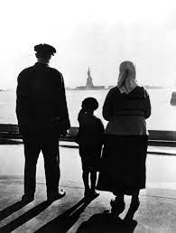
“Family Preparedness Plan” which discusses how they will address
any immigration emergency that might occur.

This pamphlet provides information on:
- Making a childcare plan if you are concerned about being deported
and want to leave your child in the United States,
- Where to find trusted legal counseling in your local community
or New York State; and
- How to prepare so you can assert your constitutional rights
in the presence of an immigration officer.

SECTION 2 - GETTING LEGAL HELP
Finding out your legal options to obtain a specific immigration status may be the strongest way for you to protect yourself and your family from deportation. This section helps you find expert legal immigration advice.
WHERE TO FIND A TRUSTED LEGAL SERVICES PROVIDER IN YOUR AREA
Getting legal advice and help from a trusted legal expert is crucial in your family preparedness planning effort because an immigration attorney, a legal services organization, or a Department of Justice accredited representative, who is authorized to provide immigration law advice and help through a non-profit organization, can help you determine if you are eligible for any immigration visa program.
The Immigration Advocates Network’s “National Immigration Legal Services Directory” lists nonprofit organizations that provide free or low-cost immigration legal services. Here is how to find legal services organizations working in New York State. Simply go to the below website:
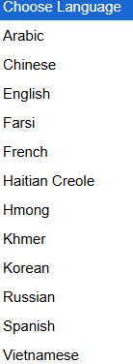
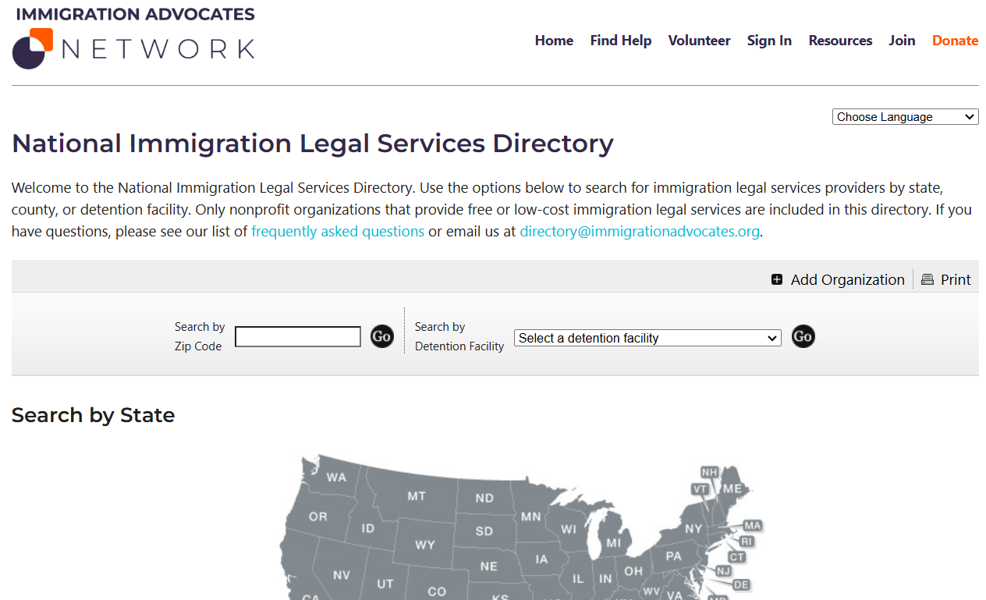
https://www.immigrationadvocates.org/nonprofit/legaldirectory/
This website can provide the displayed information in these different languages...
Go to the above website, then click on “NY” in the website’s displayed map...
After you clicked on “NY”, a legal services directory of New York State organizations will appear. This directory lists 179 organization in NYS that will help immigrants out. Below is information displayed on the American Civic Association (ACA) that serves the Broome County area.
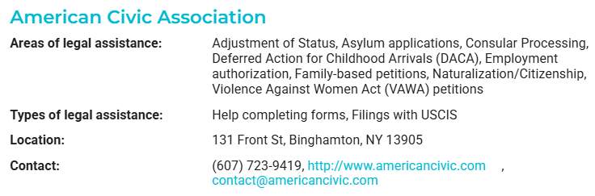
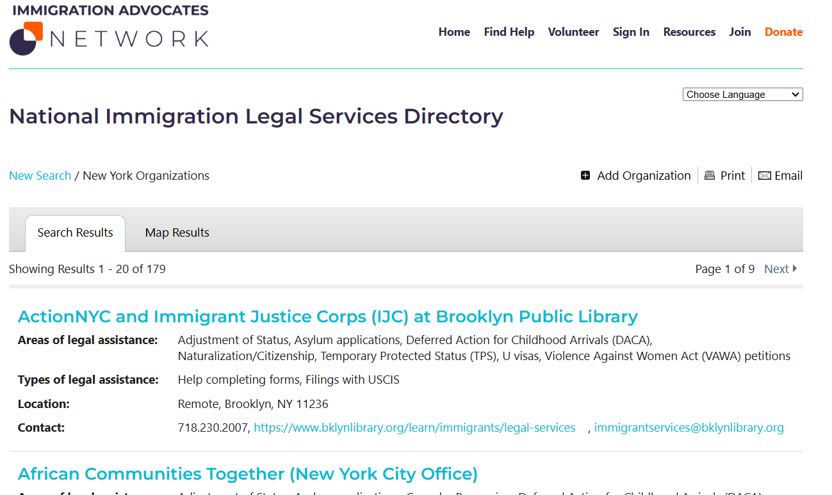

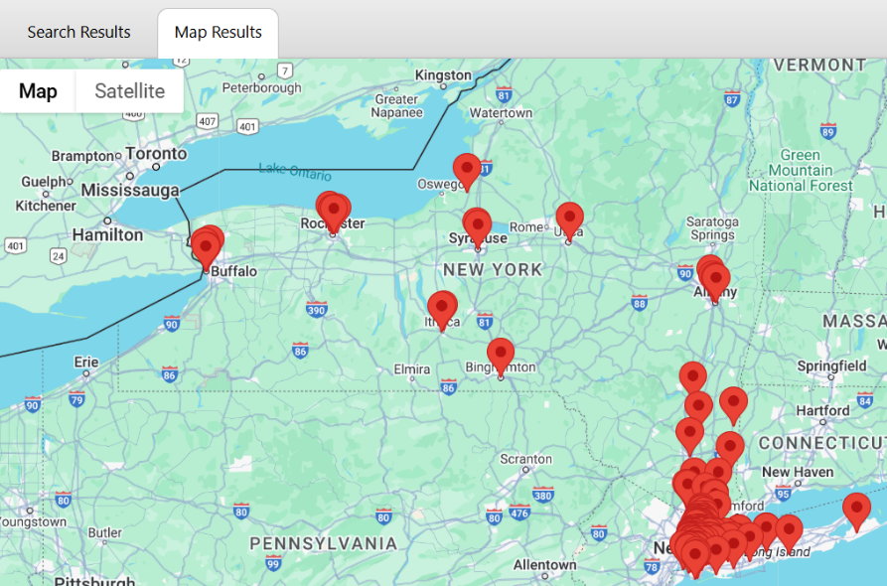
When you click on “NY” in the United States
map displayed on the Immigrations Advocates
Network’s website, a New York State directory
of trusted legal services organizations will
appear.

If you then click on the “Map Results”
tab, a New York State map will appear and
reveal each legal services organization

location within the state by displaying a red data
points for the location of this organization.

By clicking on any red data point,
you can obtain specific information on the
legal services organization at this location.

Finally, the National Immigration Legal Services Directory’s listing of the New York State legal services organizations for immigrants can also list only the organizations that, say, have expertise and / or experience in DACA matters. By using the “Refine Search” filter option displayed at the bottom of any directory listing, you can first open up one of the refined search categories listed like the “Areas of immigration legal services” by clicking on the “+” sign, then select one of the subcategories listed like the “Deferred Action for Childhood Arrivals (DACA)” category by clicking on the box in front of this category’s name. Finally, click on the “Refine Search” button. The final listing now displays only organizations that have experience in DACA matters!
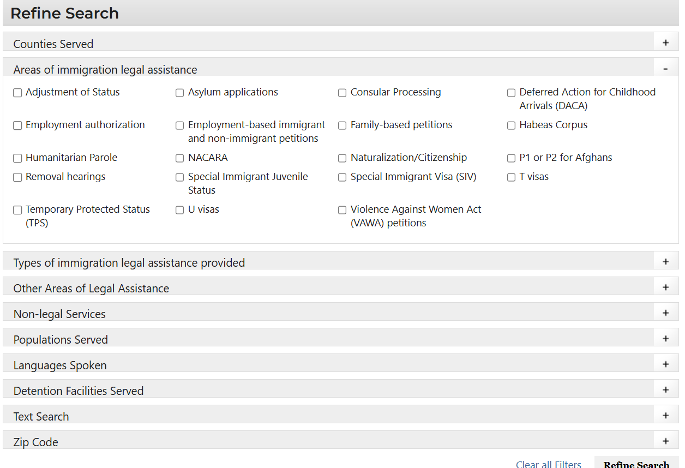
In the Broome County area, you can find legal help at:
- The American Civic Association - a nonprofit organization that is committed to helping immigrants and refugees start a new life in our community while preserving their ethnic and cultural diversity.
Address: 131 Front Street, Binghamton, NY 13905
Phone: (607) 723-9419
Fax: (607) 723-0023
Email: contact@americancivic.com
- The Legal Aid Society of Mid-New York, Inc. - Binghamton - a not-for-profit corporation which gives free civil legal information, advice and representation to residents of Broome, Cayuga, Chenango, Cortland, Delaware, Herkimer, Jefferson, Lewis, Madison, Oneida, Onondaga, Oswego, and Otsego.
Address: 105 Court Street 3rd Floor, Binghamton, NY 13901
Phone: (607) 231-5900
HelpLine: 1-877-777-6152 to access services
Website: https://www.lawhelpny.org/organization/legal-aid-society-mid-new-york-binghamton

- Journey's End Refugee Services - Through the NYS Office for New Americans and the Liberty Defense Project, Journey’s End offers complete immigration legal representation to low-income refugees, asylees, and other immigrants.

Address: 59 Court Street, 2nd Floor, Binghamton, NY 13901
Phone: (607) 235-3202
Text: (716) 364-8363 Text and WhatsApp
Website: https://www.immigration.binghamton@jersbuffalo.org

Journey’s End Refugee Services – 2025 Legal Consultation days at the Binghamton ACA office or via phone from 9AM - 3PM on February 4 & 20 - March 4 & 20 - April 1 & 17. See ACA’s website for future dates.
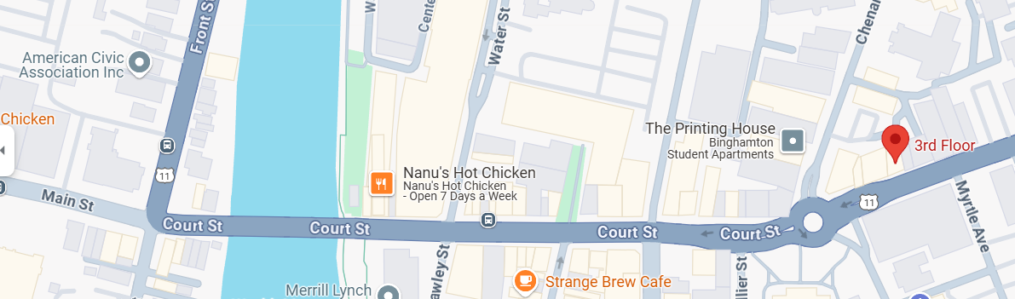
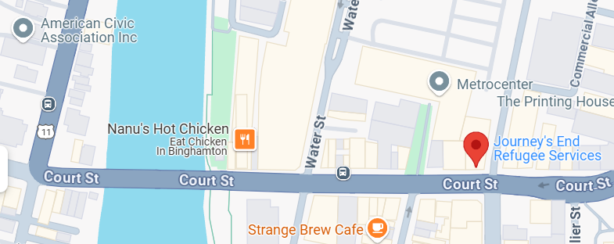
UNDERSTAND WHO CAN GIVE IMMIGRATION LEGAL ADVICE
Before you read this section, please become familiar with the previous section WHERE TO FIND A TRUSTED LEGAL SERVICES PROVIDER IN YOUR AREA which discusses the Immigration Advocates Network’s “National Immigration Legal Services Directory”. This directory lists “trustworthy” nonprofit organizations that provide free or low-cost immigration legal services.
The best way to avoid fraud in legal representation is to look for legal services providers that meet certain requirements. This can be hard if you are unsure of where to begin the search or what kinds of duties a legal representative traditionally provides for their clients. There are two categories of individuals / organizations who can give legal advice on immigration matters and / or represent you in an immigration hearing.
- Attorneys
“Immigration” attorneys give legal advice, help file immigration petitions and requests, and represent individuals in court proceedings before a U.S. District Court’s immigration judge.
Because there so few immigration attorneys in upstate New York, you should first go to a “Family Law” attorney if you need legal help on matters related to your child’s caregiver agreement or guardianship, or to a “Wills and Estates” attorney if you need legal help creating a power of attorney document and your last will and testament.
To practice immigration law, which is federal law, an attorney can be licensed in any state but must have a valid license and be ‘in good standing’ with the New York Department of State. A New York Certificate of Status (commonly referred to as a New York Certificate of Good Standing) is a document issued by the State certifying that the attorney’s business entity exists and is in compliance with state requirements.
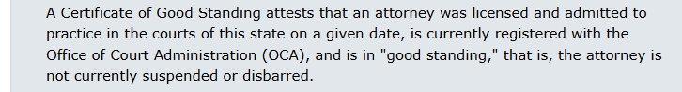

You can verify an attorney’s credentials and see if they are licensed to practice law in New York State by going to the below website:
https://iapps.courts.state.ny.us/aronline/FAQ?2#CertificateOfGoodStanding
The U.S. Department of Justice also keeps a list of attorneys who are no longer allowed to provide legal advice on federal immigration laws. Go to the below website to find this information:
https://www.justice.gov/eoir/list-of-currently-disciplined-practitioners
WHAT TO EXPECT FROM YOUR ATTORNEY
These are some of the best practices you should expect from your attorney. You should be:
- Given a Signed Contract - You should be provided with a written contract which outlines the services that the attorney will be providing and what fees the attorney will be charging you.
- Kept Informed About Your Case – An attorney should keep you informed about the progress and status of your case. They should explain the immigration benefit you qualify for, the application process, and answer any questions you might have.
- Given Copies of All Documents Related to Your Case – An attorney should give you a copy of all documents submitted on your behalf as well as copies of any receipt notices they receive from the U.S. government. They should never refuse to give you a copy of these documents or your file. In most cases, an attorney should not charge you to get a copy of your file unless you agreed to pay for photocopies in your original contract agreement with the attorney.
- Department of Justice (DOJ) Accredited Representative

A “DOJ accredited” representative is a non-attorney who has been certified by the DOJ to work on immigration matters. The person must be affiliated with a non-profit organization that is recognized by the DOJ. An “accredited” representative can give legal advice on immigration matters, file immigration applications, and, if fully accredited, represent clients in immigration proceedings. Go to the below website to find accredited organizations within New York State:

https://www.justice.gov/eoir/page/file/942306/dl#NEW%20YORK

In the displayed table provided by this website, the New York State
orginizations can be found on pages 96 thru 112. The Binghamton
organizations are on pages 96 and 97.

Recognized Organizations and Accredited Representatives Roster by State and City
The R&A Program allows certain individuals – specifically, non-attorney employees and volunteers of qualifying non-profit organizations – to practice immigration law before the U.S. government. Below is a snapshot of the Department of Justice’s (DOJ) acccredited organizations in the Binghamton area. The below displayed DOJ R&A Program Report was updated on 01/13/25.
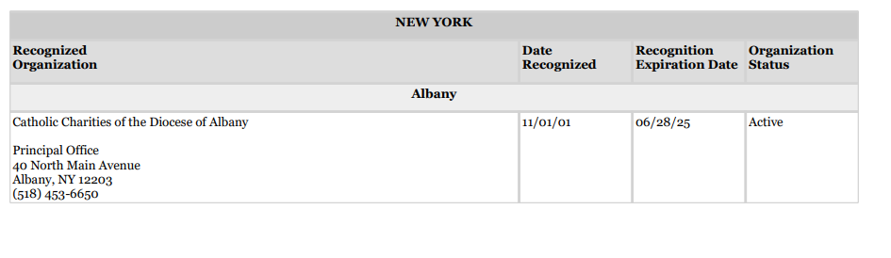
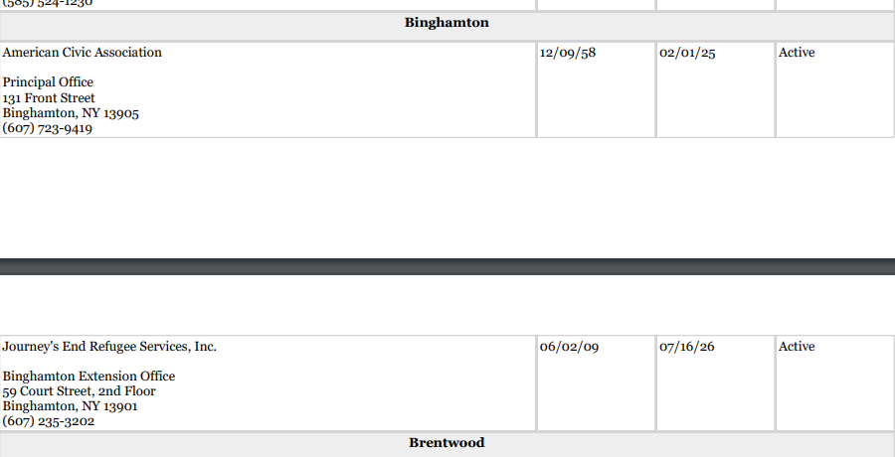

Other Important Points Relayed to Immigration Law and Deportation
- Having a child, who was born in the United States and has been granted birthright citizenship, does not shelter an undocumented immigrant parent from being deported.

- Being in the U.S. illegally is a “civil” offense, not a criminal offense. Under the “8 USC 1325: Improper Entry by Alien” immigration law; for first time offenders, the penalties for crossing the US border illegally are a fine, or imprisonment for not more than 6 months, or both. This is why the U.S. Dept of Justice’s Immigration Courts are civil courts, not criminal courts.
U.S. Supreme Court Opinion: Arizona v. United States, 567 U.S. 387 (2012)
The U.S. Supreme Court 2012 opinion established that “it was not a crime for a "removable alien" to remain in the U.S.” Thus, simply being in the U.S. cannot form the basis for an undocumented immigrant being branded as a “criminal.”

Cancellation of Removal
An undocumented immigrant can request a “cancellation of removal” during an immigration hearing. This status prevents the U.S. Citizenship and Immigration Services (USCIS) from deporting an individual to a country where their life or freedom would be endangered. The individual is basically asking the immigration judge to cancel their removal order and change their citizenship status to a lawful permanent resident of the U.S. (i.e. Make them a Green Card holder).
Since this process can be complicated, may take years to complete, and requires proof that the immigrant’s life or freedom is endangered, an undocumented immigrant should consult with an immigration attorney to evaluate if they should pursue a “cancellation of removal” application.
To be eligible to file a “cancellation of removal” request, an undocumented immigrant must establish that they:
- Have been physically present in the United States for a continuous period of 10 years
(Note: To Do List: Evidence - Since it is important to have copies of old electric & gas bills, phone bills, doctor bills, or other documents in your name which were issued ten or more years ago, start pulling these pieces of evidence together right now and placing them in your fire-proof box!)
- Have been a person of “good moral character” during this 10-year period
(Note: To Do List: Evidence – collect statements from your local priest, community leader, or manager at work, etc. and put them in your fire-proof box),
- Do not have any disqualifying criminal convictions, and
- Have a US citizen or lawful permanent spouse, parent, and/or child under 21 years of age, who would suffer “exceptional and extremely unusual hardship” if they are deported.
See US Department of Justice’s “Cancellation of Removal” flier:
https://www.justice.gov/eoir/page/file/1596141/dl?inline#:~:text=This%20may%20take%20years.,known%20as%20lawful%20permanent%20residence.

- When someone is deported, they can be sent to a country other than their country of origin, if their homeland is unwilling to accept them, or, if they have a legal connection (i.e. dual citizenship) to another country that is willing to receive them. The Department of Homeland Security’s normally deports individuals to their country of origin, but this may drastically change under Trump’s administration.
- Voluntary Departure versus Deportation
Voluntary departure permits an individual, who would otherwise be deported from the United States, to depart the U.S. at their own expense within a designated period of time. Please note that a grant of voluntary departure by an immigration court judge is not always available in all deportation cases.
Voluntary departure is preferable to a removal order for a number of reasons.
- If an individual is issued a removal order, they may be barred from re-entering the United States for up to ten years, and may be subject to civil and criminal penalties if they attempt to re-enter the United States without proper authorization. In addition, an individual with a removal order cannot apply for a cancellation of removal, adjustment of status, and other immigration benefits for a ten-year period.
- If the individual voluntarily departs the United States within the time ordered by the court, they will not be barred from legally re-entering the United States in the future. And they may have some flexibility to decide where they go.
Remember, an undocumented immigrant’s voluntary departure is not viewed as a forced removal or deportation thus there are no restrictions (i.e. a ten-year waiting period) on when the individual can seek to reenter the United States.
- Returning to the United States after Deportation
When an undocumented immigrant is deported, they are not allowed to re-enter the United States for a specific period of time. Factors that determine the period of time a deported person cannot re-enter the United States depend upon:
- Reason for Deportation
Whether the deportation was for a crime, multiple illegal entries, or other reasons.
- Length of Stay within the United States
How long the undocumented immigrant lived in the United States.
- Whether the Undocumented Immigrant was Convicted of a Serious Crime
Whether the undocumented immigrant was convicted of an aggravated felony.
How long must a deported person wait before they can seek re-entry into United States?
- 3-Year or 10-Year Bar from Returning to the United States
If you were unlawfully present in the U.S. and left before, during, or after removal proceedings begun, you could face a three or ten-year ban from re-entering the United States depending on how long your stay in the U.S. was.

- 5-Year Bar from Returning to the United State
If you were immediately removed upon illegally entering into the U.S., you could face a five-year ban from re-entering the United States.
- 10-Year Bar from Returning to the United States
If you were ordered to be removed by a judge and left the U.S. while the order was pending, you could face a ten-year ban from re-entering the United States.
      - 20-Year Bar from Returning to the United States
If you were deported and already removed on a prior occasion, you could face twenty-year ban from re-entering the United States.
- Permanently Bar from Returning to the United States
You may be permanently barred from re-entering the U.S. again if you were convicted of an aggravated felony, or entered the U.S. illegally after already been deported.
To re-enter the United States after being deported, a noncitizen must:
- Wait the required number of years, and
- File a request for “consent to reapply for admission” to the United States while living in another country.
Attempting to re-enter the United States without advanced permission could result in an increased barred re-entry penalty, potential fines, and potential jail time.

- Green Card / Permanent Residency Petition for Immigrant Parents
An immigrant parents’ child, who is a U.S. citizen and at least 21 years old, can petition for their immigrant parents to become lawful permanent residents (LPRs) in the United States. This process is called sponsoring a parent for a green card. Below is a brief summary of this process:

Eligibility for Filing a Petition

The immigrant parents’ child must be a U.S. citizen and at least 21 years old.

The parents must be “immediate relatives” of the child (i.e. The parents, children, or spouse of a U.S. citizen are considered “immediate relatives”).

Application Process

File Form I-130, Petition for Alien Relative. There is a filing fee for the petition and a $165 USCIS Immigrant Fee.

Wait for the petition to be approved. The approval process can take 10 to13 months for immediate relatives.

If the petition is approved, the National Visa Center (NVC) will forward it to the appropriate U.S. consulate in the immigrant parents’ country of residence.

The U.S. consulate will notify the parents when their visas are available.

When in the United States, the parents must use Form I-485 to apply for lawful permanent resident status (Green Card).
For more information, go to this website: https://www.uscis.gov/green-card

