FAMILY
PREPAREDNESS
PLAN
FOR
NEW YORK STATE

IMMIGRANTS


In today’s uncertain times, it is very important for an immigrant family to create a

“Family Preparedness Plan” which discusses how they will address
any immigration emergency that might occur.

This pamphlet provides information on:
- Making a childcare plan if you are concerned about being deported
and want to leave your child in the United States,
- Where to find trusted legal counseling in your local community
or New York State; and
- How to prepare so you can assert your constitutional rights
in the presence of an immigration officer.

SECTION 1 – CREATING A CHILDCARE PLAN
In the process of creating your Family Preparedness Plan, one of the most important tasks is to decide whether your child / children will accompany you back to your homeland if you are being deported.
If you decide your child will be safer and better off by staying in the United States (i.e. because there is a war or significant gang violence in your homeland; because of climate change, you cannot earn enough to support your entire family in your homeland; because your child is part of the LGBTQ community and would be persecute if they returned to your homeland; etc.), then creating a childcare agreement with another adult should be done right now!

DECIDING WHAT KIND OF CHILDCARE AGREEMENT YOU WANT TO PUT IN PLACE

Your childcare agreement can be:
- An informal, verbal agreement between you and another adult;
- A formal, legal written agreement between you and another adult, or
- A formal, legal guardianship set up by the Court and involving another adult.
Each of these childcare agreements center around selecting another trusted adult, who is 18 years or older, and, who is a citizen of the United States or in the U.S. legally. If possible, you should select a U.S. citizen or a person in the U.S. legally (i.e. a person who has a Green Card or temporary visa) as your child’s caregiver because an undocumented immigrant caregiver might also face deportation and further disrupt your child’s life.

The following caregiver agreements are appropriate for children who are a U.S. citizen or not a U.S. citizen. Additionally, these agreements can become effective when a specific event or date occurs (i.e. on the day you are deported) so the agreement does not need to become effective immediately or while you are still living in the United States. Finally, the information provided in this section is for educational purposes only. It does not, and is not intended to, constitute legal advice.

Some of the childcare agreements available in New York State are an:

1. Informal Verbal Agreement with the Caregiver
To create this informal childcare agreement, you basically need to talk to another trusted adult, who is a U.S. citizen or in the U.S. legally (i.e. a Green Card or visa holder), and ask them if they would take care of your child if you are deported. The selected caregiver must agree to carry out your wishes and raise your child when you are no longer in the United States. The benefit of this verbal agreement is that it is informal and easy to set up. You do not need to see an attorney or complete any forms / legal documents to initiate this agreement. This “handshake” agreement does not affect your parental rights to make decisions on your child’s care even if you are not living in the United States.
The downside of this informal childcare agreement is that your chosen caregiver will NOT have legal authority to make medical or school-related decisions on behalf of your child. This will be problematic if you are deported and unable to physically care for your child during an extended period of time.

2. Formal Legal Agreement Where You Designate a Caregiver by Using
New York State’s “Designation of Person in Parental Relationship” (OCFS 4940)
This legal childcare agreement can be created if you and another trusted adult, who is a U.S. citizen or in the U.S. legally (i.e. a Green Card or visa holder), complete New York State’s Office of Children and Family Services (OCFS) “Designation of Person in Parental Relationship” (OCFS 4940) form and sign it in the presence of a notary*. The NYS form legally designates a person to act as your child’s caregiver and to be responsible for providing food, shelter, clothing and other essential things the child might need plus physical and emotional support.
You don't need to see a lawyer to complete the OCFS 4940 form, but you might want to consult with a “Family Law” attorney to better understand, whether this approach or having the Court appoint a guardian, is best for your child.
In the OCFS 4940 form, a parent can limit the:
- Caregiver's decision-making authority to a specific period of time and / or
- Type of decisions the caregiver can make about the child’s education, medical care, and other matters.
The benefit of this approach is that, when you are living in another country, a copy of this legal agreement can be given to your child’s school and / or health care provider so that your chosen caregiver can make certain decisions for the child. Also, this legal childcare agreement does not affect your parental rights (i.e. you will still have custody and control of your child) and the agreement can be terminated at any time.
* A notary is a government-authorized person who verifies the document signer's identity, then witnesses the signing of the legal document. An attorney’s office, a bank, or a UPS Store usually has a notary available to witness your signature.
More information about the “Designation of Person in Parental Relationship” (OCFS 4940) form is provided in the Appendix of this pamphlet. This form is available on-line in the following languages - Arabic, Bengali, Dari, English, Haitian Creole, Korean, Polish, Russian, Urdu, and Yiddish. To printout a Word document copy of the OCFS-4940 form in one of the above specified languages, please go to the below website:
https://ocfs.ny.gov/forms/index.php?find=4940&lang=%25&topic=%25

Note: New York State’s “Parental Appointment of Your Child’s Caregiver for 12 Months or Less” form is not being referred to in this Family Preparedness Plan pamphlet because it is only valid for 12 months or less, and it is assuming that most immigrant parents will want the caregiver’s agreement to be valid for more than 12 months.

3. Formal Legal Agreement Where the Court Appoints a Guardian
This legal childcare agreement is set up by having a New York State Court appoint a legal guardian for your 17 years or younger child. You will most likely need an attorney to file a petition with the Court requesting this guardianship and to represent you during any Court hearings on this request. Also note that you do not need to be present during the guardianship Court hearings.
As the child’s legal guardian, the individual has full legal and physical custody of your child and can make decisions on where the child lives, what they eat, what medical care they receive, where they go to school, etc.
Appointing a guardian does not mean that you no longer have any parental rights. The Court may specify unique conditions for each guardianship, and, say, allow you to keep your right to make long-term, major decisions on the child’s medical care or education. Finally, guardianships usually end when the child becomes 18 or 21 years old.
When a guardian is appointed by the Court, this action may suspend some or all of your parental rights while the guardianship is in place. To restore your parental rights, you must file a petition in Court requesting that the Court terminates the guardianship. A Judge must then decide on whether terminating this guardianship is in the best interest of the child.
In New York State, you cannot informally grant another person guardianship of your child. A Court Judge is the only one who can legally appoint a guardian to oversee your child’s care.

Since it is a serious decision to have the Court appoint a guardian, please discuss this approach with a trusted legal services provider or organization who specializes in family law. An immigration attorney’s help is not need in this legal process. For more information on NYS guardianships, please click on the below links:

For more information - https://nycourts.gov/CourtHelp/Guardianship/index.shtml

For petition form - https://ww2.nycourts.gov/forms/surrogates/guardianship.shtml

Other Important Points Related to a Childcare Agreement & Family Deportation
- Presently, under the U.S. Constitution’s Fourteenth Amendment, Section 1, U.S. citizenship is automatically granted to a baby when they are born in the United States.

- If your child is NOT a U.S. citizen and you elect to have the child remain in the United States when you are facing deportation, the child may seek relief from deportation by requesting asylum (i.e. They may seek asylum because, for example, they and their family members are in danger of being killed by a local drug cartel in their homeland, etc. - Remember, the child needs to prove this condition exists in their homeland area where the family used to live!). If the non-U.S. citizen child is trying to remain in the United States, you should also create one of the fore-mentioned childcare agreements so the child will be cared for by a loving adult who you have chosen, and will not be placed in a foster care program.
- The Trump administration’s ICE agents will be encouraging families with a U.S born child to
be deported TOGETHER. This “keeping the family together approach” may not be the “best solution” for undocumented immigrant families!

Undocumented immigrant parents should ask an immigration attorney whether they should let
their child, who is a U.S. citizen or not a U.S. citizen, stay in the United States if the parent is being deported and the parent seriously fears for their child’s safety or well-being in their country of origin?

Besides focusing on the safety and well-being of their child, the parent’s legal consultation should also center around:
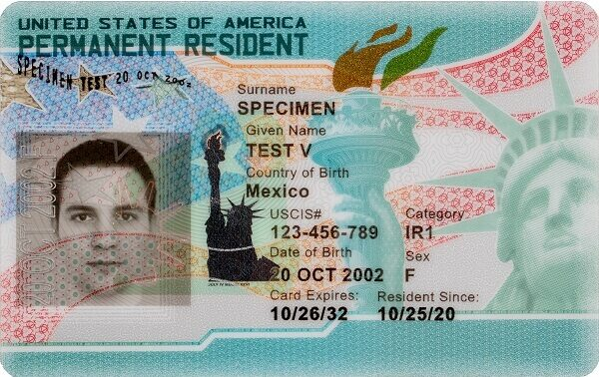
Whether there are any advantages of having their
U.S. citizen child stay in the United
States so, when they turn 21 years old, they can
sponsor their immediate relatives (immigrant
parents, spouse, and/or child living in another
country) for permanent residency in the United
States (i.e. file a Form I-130, Petition for Alien
Relative, so the relative can get a Green Card
/ Permanent Resident Card).

For more information, go to the below website.

https://travel.state.gov/content/travel/en/us-visas/immigrate/family-immigration.html

Whether there are any advantages of having their non-U.S. citizen child stay in the United States and have this child’s 21-year-old or older U.S. citizen brother, sister, or parent seek to sponsor the immigrant child for permanent residency in the United States under the F4 family-based preference category. For more information, go to the below website.

https://www.uscis.gov/green-card/green-card-eligibility/green-card-for-family-preference-immigrants

NOTE ON NEW YORK STATE’S “POWER OF ATTORNEY” DOCUMENT
A “power of attorney” (POA) is a written legal document that you can sign to grant another person the authority to act on your behalf in specified ways. For example, a power of attorney document may be used to designate another person to handle your finances, make business decisions, use your money to pay your rent or mortgage, use your money to provide for your child’s care, etc. This power of attorney document would be useful if you think you are going to be deported and own a home and business in the U.S., OR, if you want to have someone withdraw money from your U.S. bank account and give it to your child’s caregiver, etc.
New York State also has a “New York Minor (Child) Power of Attorney” document that can be used to give another person decision-making power over your child’s education, health care, and finances for a period of up to 12 months and is normally set in place when the parent(s) or guardian(s) of the child anticipates being unavailable. Again, it is assumed that most immigrant parents will want to set up a child care arrangement for more than 12 months so they are encouraged to use New York State’s “Designation of Person in Parental Relationship” (OCFS 4940) form.

“TO DO” LISTS SUMMARY
Below is a brief summary of the action items recommended for undocumented immigrants who may face deportation. The items in this “To Do” list will be discussed in greater detail in the forthcoming pages.
- Make up a family preparedness plan
- Talk to your family and friends about your plan
- Create a sheet listing the phone numbers of contacts who should be called if you are detained by ICE – family members, attorney, etc.
- Create a sheet on each child’s medical history – medicine taking, immunizations, health conditions, doctors, health insurance, etc.
- Purchase a fire-proof box within which you can store your important financial and personal papers, child’s medical history and birth certificate, etc.
- Get your financial affairs in order – create a Power of Attorney and Last Will & Testament
- Find an immigration attorney or legal services organization that could help you if you are detained by ICE
- Obtain a U.S. passport for your U.S. citizen child
- Create a plan on how you will stay connected with your family if you are deported
- Find documents that will serve as evidence to prove you have been living in the U.S. for over ten years, and obtain individuals’ statement to show you have “good moral character”. Place these documents in your fire-proof box.
- ______________________________________________________________
TO DO LIST: CREATE A POWER OF ATTORNEY AND WILL
If there is any chance you might be deportation, talk to a “Wills and Estates” attorney or the local Legal Aids Society and see about creating both a power of attorney and a will so your assets are protected and secured for your children and other family members. A:
- Power of Attorney allows you to assign someone else to take care of your financial affairs (pay your US bills, sell your property, etc.) and / or local business, and
- Will states how you want your U. S. assets, like your home or car, to be given to your children or other family members after your death.
Both legal documents help provide comprehensive protection of your estate in all situations.
A New York State “Wills and Estates” attorney or local Legal Aids Society can help you create a power of attorney (POA) document so that you do not need to discuss this matter with an immigration attorney. An attorney usually charges between $200 and $500 to create a POA document. Some non-profit organizations or community legal aid clinics may offer free or low-cost legal assistance. Below websites have two great discussions on power of attorney by the American and NY City Bar Associations:
https://www.americanbar.org/groups/real_property_trust_estate/resources/estate-planning/power-of-attorney/
https://www.nycbar.org/get-legal-help/article/wills-trusts-and-elder-law/power-attorney/
Note: there are on-line venders who will offer to help you create a Power of Attorney document “FOR FREE” but their services are not really free and the POA document created may not truly address your complex legal needs. Because a POW document gives another individual power to make financial and other very important decisions for you, you are encouraged to see a lawyer about this matter!
If you own a home, business, car, and / or other physical assets, you should also discuss setting up a Last Will & Testament with a “Wills and Estates” attorney or local Legal Aids Society. A Will defines how your physical assets will be distributed to your heirs when you die (i.e. your daughter gets ownership of your home located in the United States, etc...). A simple lawyer-drafted Will costs around $300 and some non-profit organizations or community legal aid clinics may offer free or low-cost legal assistance. The below two websites provide more information on Wills:
https://www.americanbar.org/groups/real_property_trust_estate/resources/estate-planning/intro-wills/
https://www.nycourts.gov/courthelp/whensomeonedies/will.shtml
Note: there are on-line venders who will offer to help you create a Will “FOR FREE” but their services are not really free and the generated Will may not truly address all of your complex legal needs. For example, a Will might involve giving your home, which still has a mortgage on it (i.e. you and the bank own this home), to another individual when you die. Basically, the other individual only inherits part ownership of this home after you die, so you should see a lawyer and discuss how your Will can transfer your equity in this house to another individual.
If you have a bank / savings account, 401K / IRA account, stocks, life insurance policy, and other non-physical financial assets, you should also talk to the bank about setting up a joint banking / savings account, or to your financial planner / insurance agent about naming a beneficiary who will receive these financial assets after you die. Setting up a joint account and naming one or more beneficiaries will ensures that your financial assets will go directly and immediately to the other individual(s) when you die, and will help your heirs avoid involvement in any other legal processes like probate.
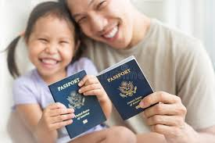
TO DO LIST: MAKE SURE YOUR U.S. CITIZEN CHILD HAS A PASSPORT
If you are an undocumented immigrant parent of a child who was born
in the U.S. and is now a U.S. citizen living in the United States,
it is recommended that you obtain a U.S. passport for your child...
This will allow them to travel with you, if you wish them to accompany
you should you be deported, or to visit you in your homeland after
you have been deported. They can then use their U.S. passport
to freely leave and re-enter the U.S. at any time.

If your child was born in the United States and is under 18 years old, you can obtain more information on applying for a U.S. passport by visiting the below websites:
Under 16 years old: https://travel.state.gov/content/travel/en/passports/need-passport/under-16.html
16 and 17 years old: https://travel.state.gov/content/travel/en/passports/need-passport/16-17.html
The below image shows the eight steps you will need to complete to obtain your child’s U.S. passport...
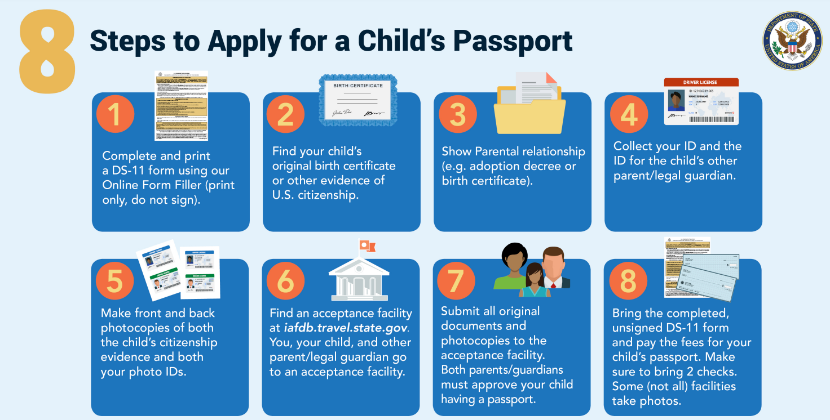

If your child was born in a different country, check with the country’s embassy or consulate located in the United States for more information on obtaining this country’s passport.

NOTE: Your local county’s Department of Social Services (DSS) office “may” offer you help to cover the $150 costs of obtaining a U.S. passport if the U.S. citizen child lives within the county the DSS office serves because:
- Getting a U.S. passport may have a positive impact on the undocumented immigrant parent’s decision on whether they should take their U.S. citizen child with them if they are deported to another country, and
- It will not place an additional financial burden on the local DSS office that would have occurred if the deported parent leaves the child behind in the U. S. and the child is placed in the county’s foster care program.
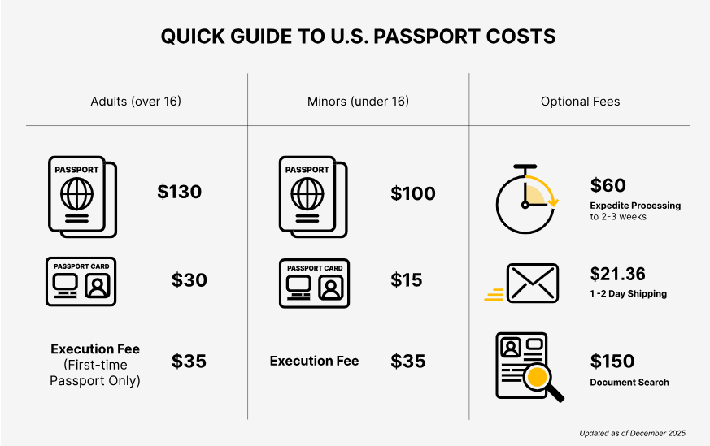

TO DO LIST: WRITE DOWN INFORMATION ON YOUR CHILD’S MEDICAL CONDITIONS, MEDICATIONS, etc...
When creating your Family Preparedness Plan, make sure

you write down on a sheet of paper, or on a copy of the
“CHILD’S IMPORTANT INFORMATION” worksheet
provided in the Appendix, any:
- Medical conditions, dental conditions, allergies, surgeries,
broken bones, or mental disabilities your child has,
- Any medications that your child currently takes or recently took,
- All of the vaccinations your child has had,
- Information on your child’s doctor(s) (their name, office location,
phone number, etc.) and,
- Information on the child’s health insurance.
You should date this document and review it every 6 months to make sure that the child’s medical history is always up-to-date! Keep a copy of this information in your “Important Papers”
fire proof box. And make sure this fire proof box is readily available in case there is an emergency and you need to obtain something from this box.

The fire proof box pictured above costs around $30 when purchased on-line.

It is also recommended that you use your smart phone and take a picture of your child’s health care information summary sheet and their health insurance policy so you can always have this information with you. Plus, if you have an email account, you can email the summary sheet and health insurance policy photos to yourself so it will be stored in a remote, secured location where the photos will always be available to you even if you break or lose your cellphone.

If you are facing deportation, give a copy of your child’s medical information sheet and health insurance coverage form to your child’s school nurse and to the adult you have designate to care for your child. Also, let your child know where the “Important Papers” fire-proof box, containing their “CHILD’S IMPORTANT INFORMATION” sheet and health insurance coverage form, is stored just in case you are not around and they need to obtain a copy of their health history and health insurance coverage for school sports, travel activity, etc.

TO DO LIST: CREATE A PLAN TO STAY CONNECTED WITH YOUR CHILDREN
When creating your Family Preparedness Plan, consider creating a positive plan that will help you stay connected with your child when you are not around. For example, you can:

- Set goals for how you want to be involved in their lives.
Ask them to mail you pictures they drew in school so
you can hang them up on a wall, set up a Facebook
account where they can post cellphone pictures on it,
write a story about your adventures in your homeland
and send it to them, etc.
- Be patient because healing during this separation
period takes time.
- Allow yourself to grieve the loss of daily interactions
with your child while remaining hopeful for the future...
TO DO LIST: TALK TO YOUR FAMILY ABOUT YOUR PLAN
Without worrying them, try to assure your children and other family members that they will be taken care of if, for some reason, you are unable to care for them. Let your children and older family members know who will care for them until you can.
Also, briefly discuss “YOUR” Family Preparedness Plan with your children, other family members, close friends, concerned neighbors, and close co-workers because they:
- May be called upon to help you if a CBP or ICE agent arrested you while you are at work (i.e. you may ask a co-worker to pick up your child at school, or to help another “at risk” family member find a safe place to stay, etc.),
- Might have other ideas on how to improve your plan, (i.e. recommend a good immigration attorney if you are facing a deportation hearing. Having an attorney present during your deportation hearing can improve your chances of not being deported by over 30%, etc.)
- Might be able to help you create a phone tree where information on CBP’s / ICE’s current activities in your community can be passed along to other immigrants (i.e. If you are detained by ICE at work, some of your co-workers might have a copy of your phone tree directory so they know who to contact about your arrest or about ICE’s activity in your community, etc.).
- Might be able to help you and other members of the immigrant community develop a closer relationship with “local” police and politicians so they get to know how much you contribute to the well-being of their community. Any opportunity you and other immigrants have to talk to local police officers about:
  - Your job constructing homes, working in a nursing home, milking cows for a local farmer, etc.
  - Owning a home, paying over $8,000 per year in federal, state and local taxes for the last 10 years, peacefully living in the community for over 15 years, never been arrested, etc.
may help dispel the image that you and other members of your community are “just” immigrants who have a different skin color and speak broken English.
Because local law enforcement officials are involved in over 50% of New York States ICE’s detentions (i.e. If a local policeman makes a traffic stop and they apprehend a person who doesn’t speak English or looks like an immigrant, they routinely contact ICE.), any effort to show the local police officials that you and others immigrants in your local community are like them – hard working people with a family - may make a world of difference in how they treat you. Try having your immigrant community set up a soccer game and picnic with local police and fire officials, get your friends involved in local field days, runs/walks/races/parades, the National Night Out, etc.
- Might realize that they should also create their own Family Preparedness Plan, power of attorney, last will and testament, etc. even though they are U.S. citizens and don’t have to be concerned about being deported!

TO DO LIST: INFORM YOUR FAMILY AND EMERGENCY CONTACTS ABOUT HOW THEY CAN FIND YOU IF YOU ARE DETAINED BY U.S. CUSTOMS AND BORDER PROTECTION (CBP) OR IMMIGRATION AND CUSTOMS ENFORCEMENT (ICE)

To locate where a person is being detained by CBP or ICE, you can use the below detainee locator website:
https://locator.ice.gov/odls/#/search
Below is a screen print of the Locator’s search page. This search engine will only locate a detainee who is currently in ICE custody, or who has been in U.S. Customs and Border Protection’s custody for more than 48 hours. It may not provide information on a detainee’s location if they have been temporarily placed in a local city or county jail.
The “A-Number” used in this search engine is a person’s “Alien Registration” number and it is printed on the detainee’s “Notice to Appear” form and other U.S. Immigration and Customs Enforcement (ICE) documents.
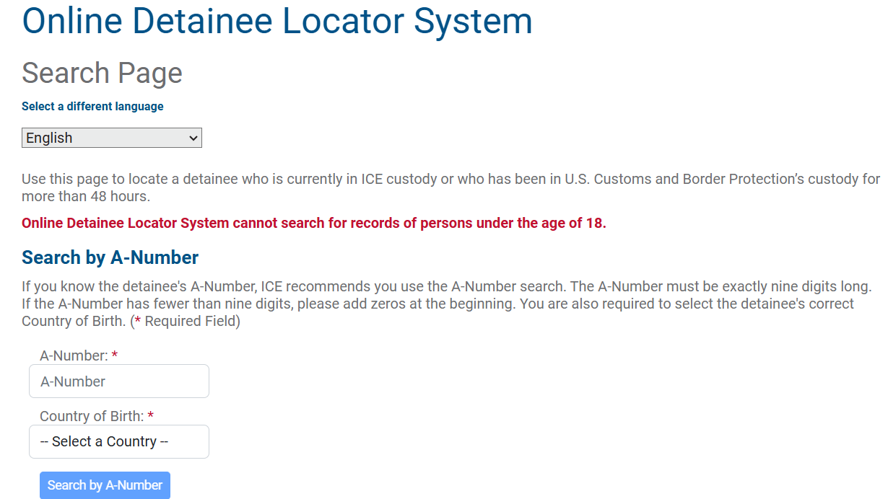
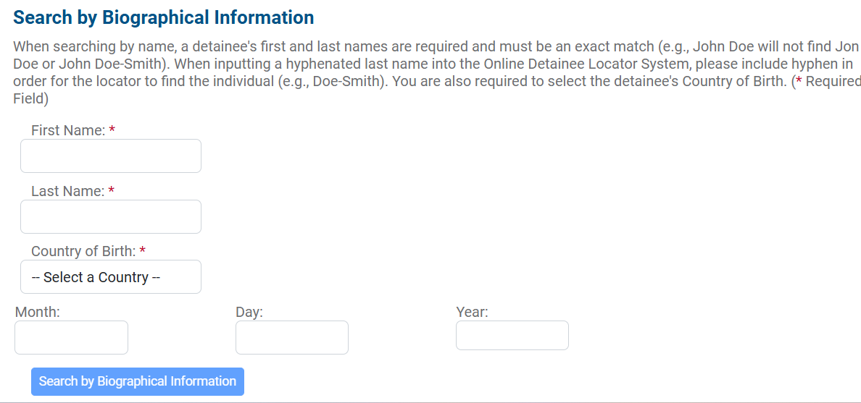
The “A-Number” can be found in the top right corner of the Notice to Appear (NTA), Form I-862 given to the detainee by CBP or ICE.

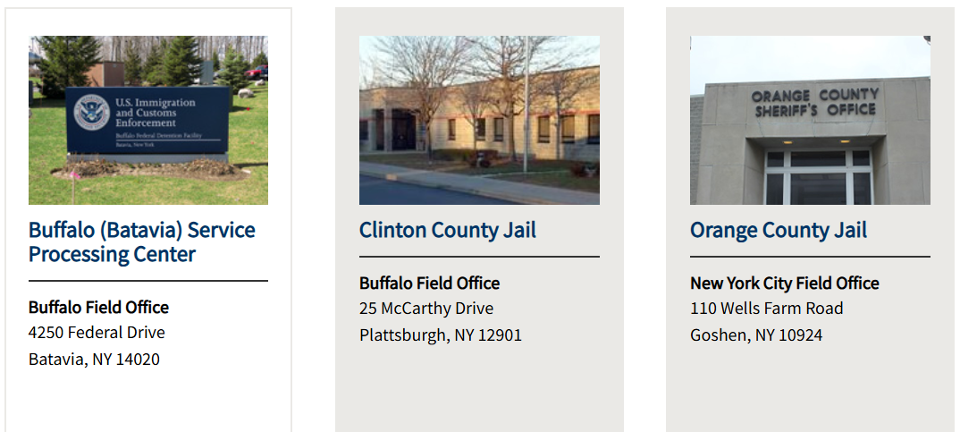
Here are the three New York State CBP / ICE detention centers currently listed on the U.S. Immigration and Customs Enforcement website.

If you go to the Immigration Advocates Network website below,
https://www.immigrationadvocates.org/nonprofit/legaldirectory/

the website lists eight detention centers, not three, in New York State...
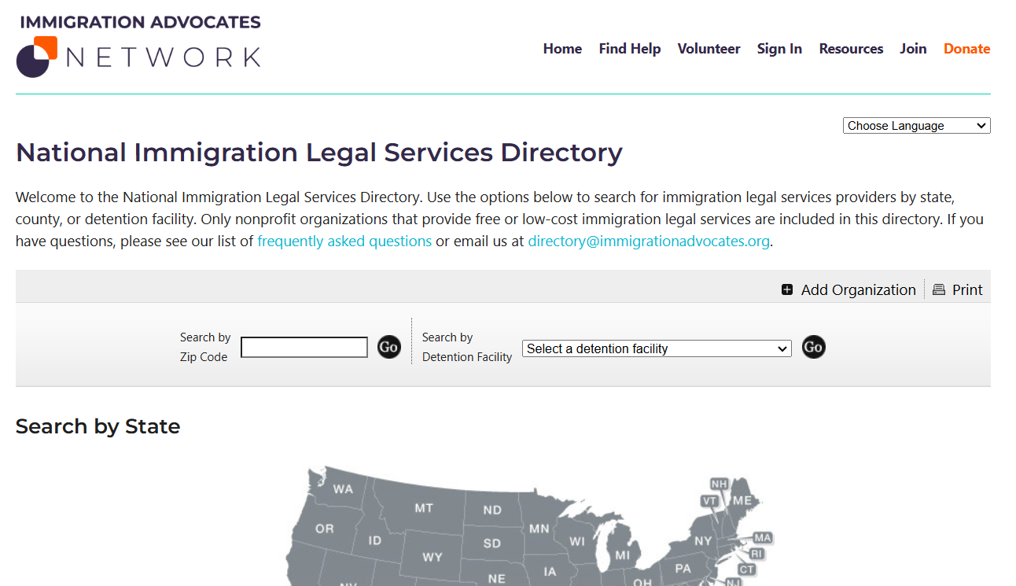

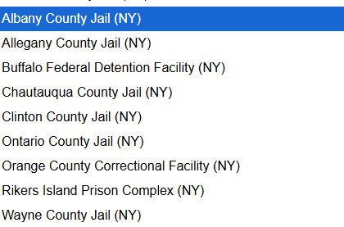
https://www.ice.gov/detain/detention-management/national-detainee-handbook

The U.S. Immigration and Customs Enforcement (ICE) National Detainee Handbook was designed to standardize the essential ICE-related information that is disseminated to all ICE detainees. The purpose of the handbook is to provide an overview of the general rules, regulations, policies, and procedures that detainees are required to follow while in ICE custody. The ICE National Detainee Handbook also provides an overview of the programs and services available while detainees are residing in an ICE-approved facility. In addition to this handbook, the detention facility will provide a local supplement to the detainee handbook that should address facility-specific items such as meal schedules, staff-detainee communication, visiting procedures, etc.
The National Detainee Handbook is currently available in 19 languages: English, Spanish, Arabic, Bengali, French, Haitian Creole, Hindi, K'iche' (Quiché)/Kxlantzij, Mam, Portuguese, Pulaar, Punjabi, Q’eqchi’ (Kekchí), Romanian, Russian, Simplified Chinese, Turkish, Vietnamese and Wolof. Where the handbook is not currently translated into a detainee’s language, the information therein (or pertinent parts) must be orally interpreted for that detainee through a professional interpreter.



