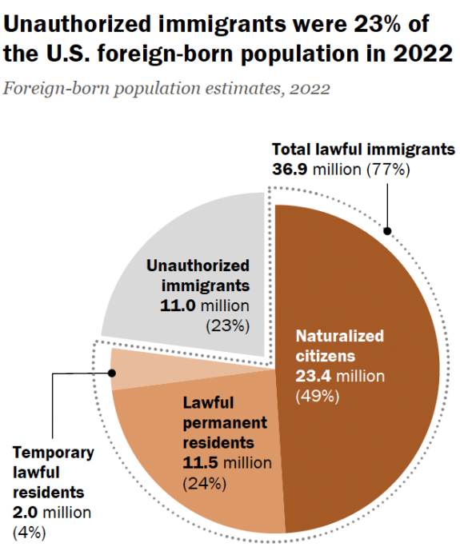
Here are some important facts about undocumented immigrants that you should know...
- 11 million undocumented immigrants were living in the U.S
in 2022. The majority of them crossed the U.S. border illegally. ¹
- 8.7 million (79%) of them have lived in the U.S. for more than
ten years. ¹
- 8.3 million (75%) of these undocumented immigrants worked
in the U.S. in 2022. They represented 4.8% of the U.S. work
force, and 22% of our agricultural workers, 15% of our
construction workers, and 8% of our manufacturing workers. ^{1, 2}
- $3.4 billion in revenues was generated by the NYS dairy
industry in 2023. The 3,034 dairy farms represent the state’s
largest agricultural sector and generate nearly half of the state’s
total agricultural receipts. ⁴
Per Cornell University, over 50% of the NYS farm workers
are undocumented immigrants, thus a majority of NYS dairy
farm workers, who care for over 630,000 cows, are most likely undocumented immigrants. ⁵
- 4.4 million U.S.- born children under 18 years of age lived with an undocumented immigrant parent in 2022. ¹
- $96.7 billion in federal & state payroll taxes, and state & local sales taxes were paid by undocumented immigrants in 2022. $32.1 billion of their payroll tax deductions when into our Social Security and Medicare programs and helped keep these programs financially sound. ³
Trump wants to deport "millions and millions" of "illegal aliens" with criminal records.
- First, being in the U.S. illegally is a “civil” offense, not a criminal offense. Under the “8 USC 1325: Improper Entry by Alien” immigration law; for first time offenders, the penalties for crossing the US border illegally are a fine, or imprisonment for not more than 6 months, or both. This is why the U.S. Department of Justice’s Immigration Courts are civil courts, not criminal courts. ⁷
Civil Offense - Defamation, breach of contract, negligence resulting in injury, property damage, etc.
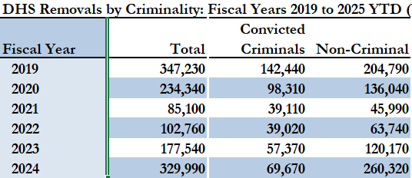
Criminal Offense – Murder, rape, arson, fraud, tax evasion, domestic violence, robbery, etc.
- Second, the U. S. Department of Homeland Security (DHS)
has been deporting roughly 60,000 convicted immigrant
criminals, not millions, each year for the last 5 years. ⁸
The U.S. Supreme Court’s 2012 opinion “Established
that it was not a crime for a "removable alien" to remain
in the U.S.” ⁹ Thus, any undocumented immigrant, who
crossed our border illegally (a civil offense), is currently living in the U.S., and does not have any previous criminal convictions, should not be identified as a “criminal." The truth is that Trump will be attempting to deport millions of undocumented immigrants who have no criminal record!
Trump’s Mass Deportation effort is traumatizing families, separating children from their parents, destroying parts of our economy that rely heavily on immigrants, and stirring up more hatred in the United States...
It is time for us to RISE UP and STOP Trump from using our valuable law enforcement resources and $88 billion of taxpayers’ dollars each year to arrest and deport millions of “non-criminal” immigrants because this action will not suppress crime in the U.S. nor stop the flow of fentanyl and immigrants at our Southern border! ¹⁰
References
1. https://www.pewresearch.org/short-reads/2024/09/27/key-findings-about-us-immigrants/#
2. https://unidosus.org/blog/2024/12/06/the-economic-costs-of-mass-deportations-of-long-time-residents/
3. https://itep.org/study-undocumented-immigrants-contribute-nearly-100-billion-in-taxes-a-year/#:~:text=%E2%80%9CThe%20bottom%20line%20here%20is,significant%20consequences%20for%20public%20revenues
4. https://agriculture.ny.gov/system/files/documents/2024/07/2023dairystatisticsannualsummary.pdf
5. https://rural.as.cornell.edu/undocumented-farmworkers-nys#:~:text=Over%2050%%20of%20the%20farmworkers%2D%2Din%20upstate%20and,New%20Yorkers%20say%20they%20appreciate%20their%20contributions.&text=Since%20there%20is%20no%20visa%20program%20for,the%20economic%20viability%20of%20the%20dairy%20industry.
6. https://www.axios.com/2024/12/05/trump-mass-deportations-ice-arrests-homicide
7. https://uscode.house.gov/view.xhtml?req=granuleid:USC-prelim-title8-section1325&num=0&edition=prelim#:~:text=(a)%20Improper%20time%20or%20place,than%202%20years%2C%20or%20both.
8. https://ohss.dhs.gov/topics/immigration/immigration-enforcement/immigration-enforcement-and-legal-processes-monthly
9. https://supreme.justia.com/cases/federal/us/567/387/#annotation:~:text=system%20Congress%20created.-,As%20a%20general%20rule%2C%20it%20is%20not%20a%20crime%20for%20a,appear%2C%20an%20in%20absentia%20order%20may%20direct%20removal.%20%C2%A71229a(5)(A).,-The%20federal%20statutory
10. https://www.americanimmigrationcouncil.org/research/mass-deportation

ICE Definitions
Arrest, administrative (administrative arrest): Detaining by Immigration and Customs Enforcement (ICE) within the interior of the United States of a noncitizen unlawfully present in the United States or of a lawfully present noncitizens who is subject to removal.
Arrest, criminal (criminal arrest): Detaining of an individual based on an alleged criminal offense, which may or may not have a nexus to immigration.
U.S. Supreme Court Opinion – It is not a CRIME for a removable alien to remain present in U.S.
“Illegal entry is defined as a crime under the U.S. Code, punishable by a fine or imprisonment. A U.S. Supreme Court opinion from 2012, however, established that it was not a crime for a "removable alien" to remain in the U.S. Therefore, simply being in the U.S. cannot form the basis for an immigrant being branded as a “criminal." According to the Supreme Court., deportation is also not a punishment for a crime but rather a civil penalty.
Arizona v. United States, 567 U.S. 387 (2012) ⁹
As a general rule, it is not a crime for a removable alien to remain present in the United States. See INS v. Lopez-Mendoza, 468 U.S. 1032, 1038 (1984). If the police stop someone based on nothing more than possible removability, the usual predicate for an arrest is absent. When an alien is suspected of being removable, a federal official issues an administrative document called a Notice to Appear. See 8 U. S. C. §1229(a); 8 CFR §239.1(a) (2012). The form does not authorize an arrest. Instead, it gives the alien information about the proceedings, including the time and date of the removal hearing. See 8 U. S. C. §1229(a)(1). If an alien fails to appear, an in absentia order may direct removal. §1229a(5)(A).

