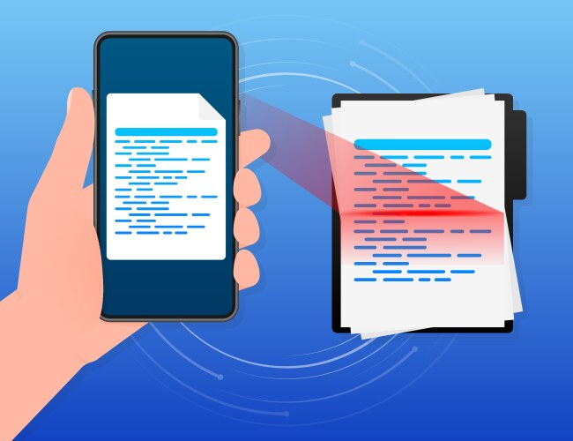
Use your cellphone to snap pictures of the English version and your own language’s version of the “Know Your Constitutional Rights” cards. Take one picture of the left side of this card and one picture of the right side of this card. This will allow you to always have this Constitutional Rights card readily available if you encounter an ICE or CBP agent and what to declare your constitionsl right to remain silent, not give them permission to enter your home or non-public work site unless they have a judicial warrant signed by a judge or magistrate, not sign anything,...
Only show the rights card’s photo images to an ICE or CBP agent through a window, BUT NEVER GIVE THEM YOUR “UNLOCKED” PHONE.
You can tell an ICE agent that you do not want them to have your cellphone, or
- Directly state your refusal: "I am not comfortable providing you with my phone." or
- Ask for justification: "Do you have a warrant to access my phone?" or
- Exercise your right to remain silent: "I would like to consult with an attorney before providing you with any information from my phone."

- For Cellphone Picture – Know Your Constitutional Rights Card – English Version
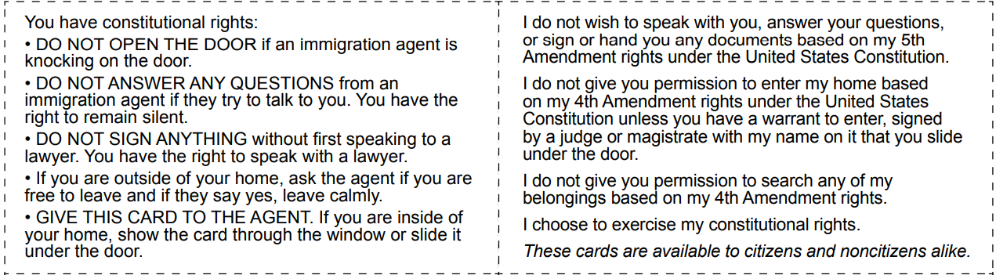

- For Cellphone Picture – Know Your Constitutional Rights Card – Amharic Version
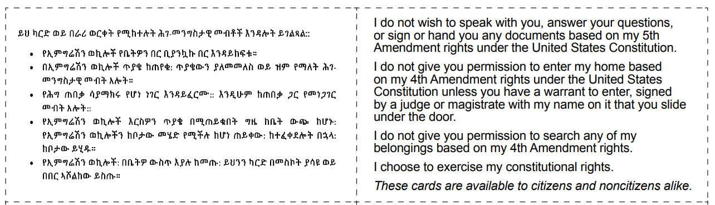

- For Cellphone Picture – Know Your Constitutional Rights Card – Arabic Version
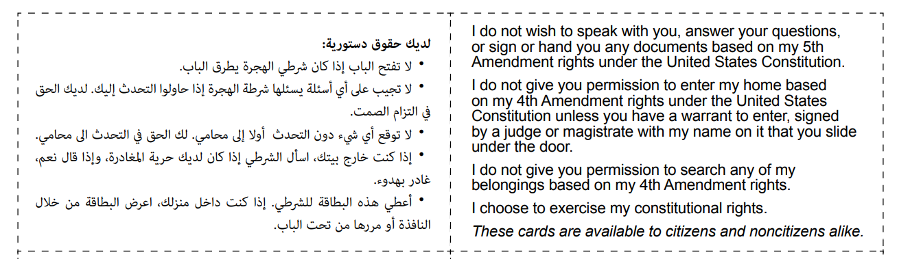
- For Cellphone Picture – Know Your Constitutional Rights Card – Chinese Version
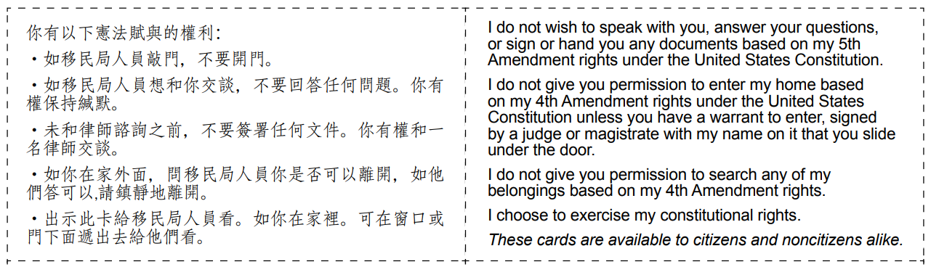
- For Cellphone Picture – Know Your Constitutional Rights Card – Farsi Version
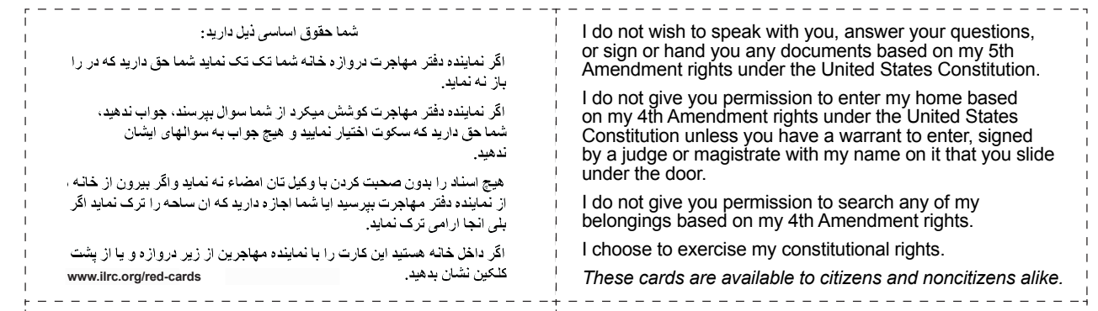
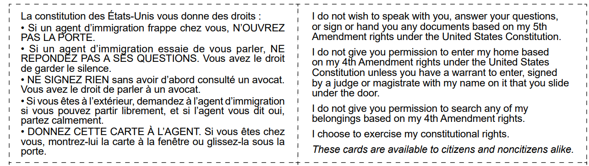
- For Cellphone Picture – Know Your Constitutional Rights Card – French Version

- For Cellphone Picture – Know Your Constitutional Rights Card – Haitian Creole Version
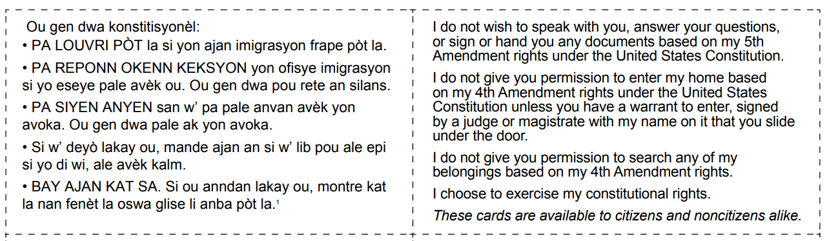

- For Cellphone Picture – Know Your Constitutional Rights Card – Hmong Version
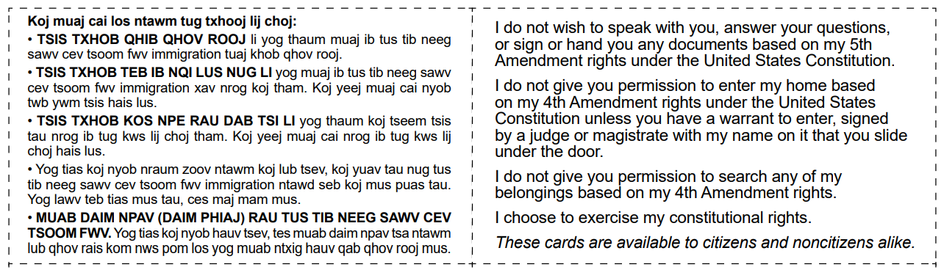

- For Cellphone Picture – Know Your Constitutional Rights Card – Khmer Version
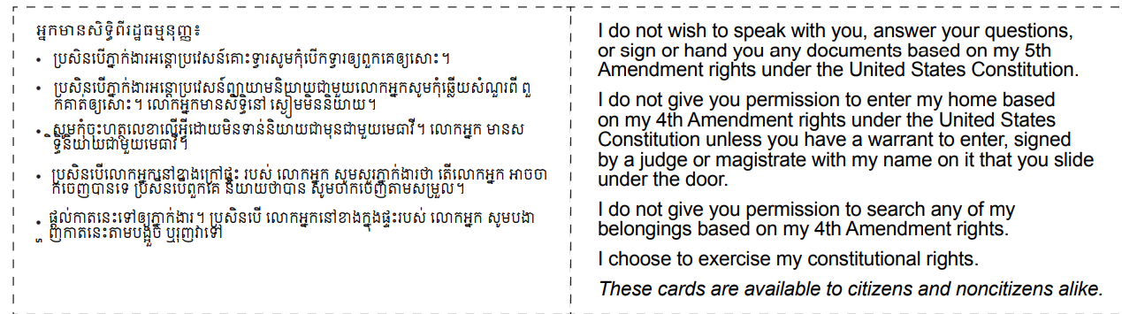
- For Cellphone Picture – Know Your Constitutional Rights Card – Korean Version
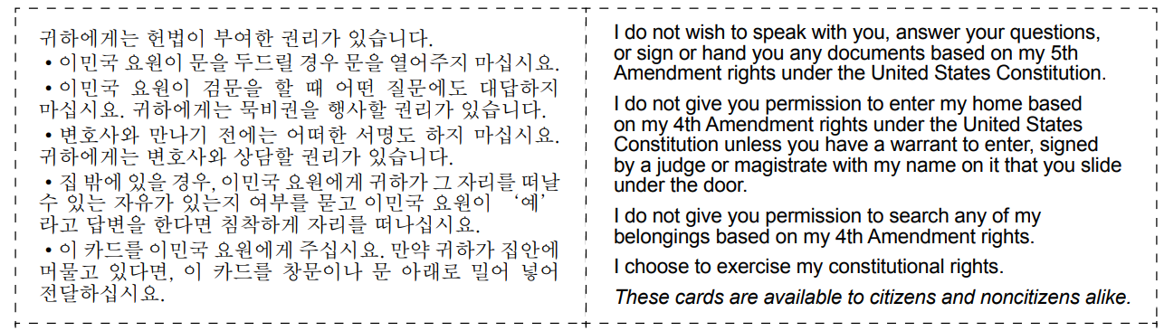

- For Cellphone Picture – Know Your Constitutional Rights Card – Pashto Version
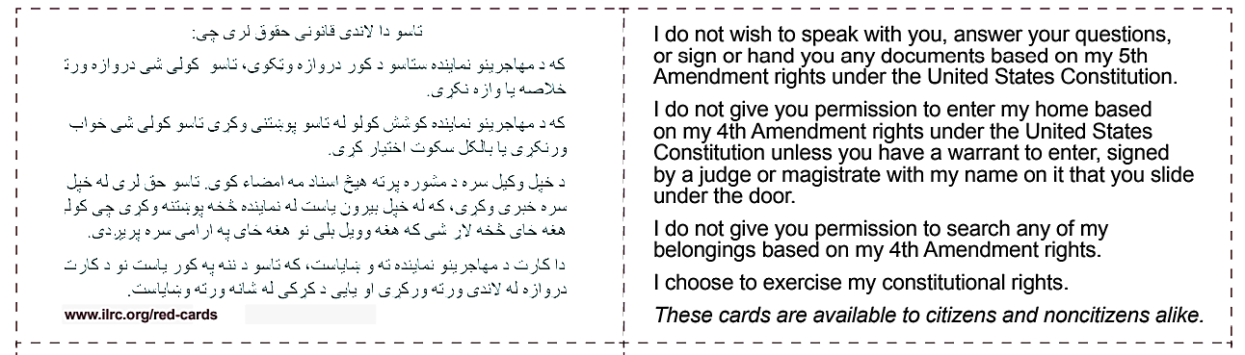

- For Cellphone Picture – Know Your Constitutional Rights Card – Portuguese Version
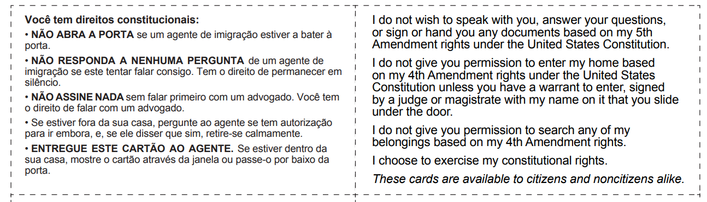
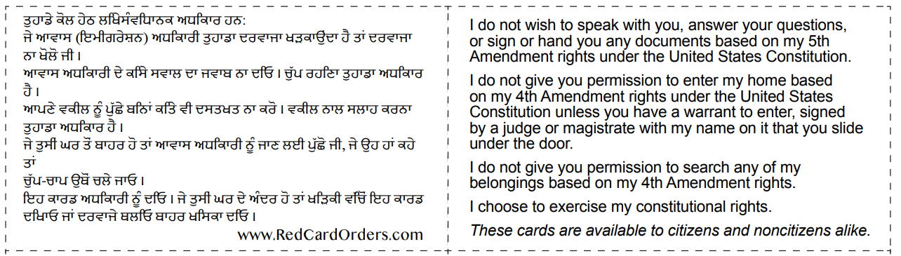
- For Cellphone Picture – Know Your Constitutional Rights Card – Punjabi Version

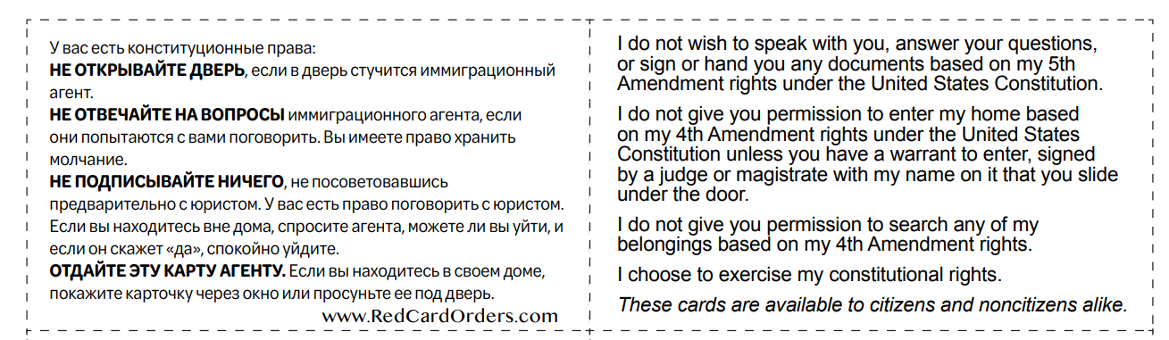
- For Cellphone Picture – Know Your Constitutional Rights Card – Russian Version

- For Cellphone Picture – Know Your Constitutional Rights Card – Spanish Version
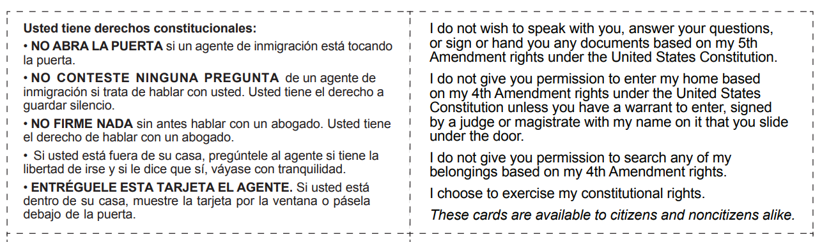

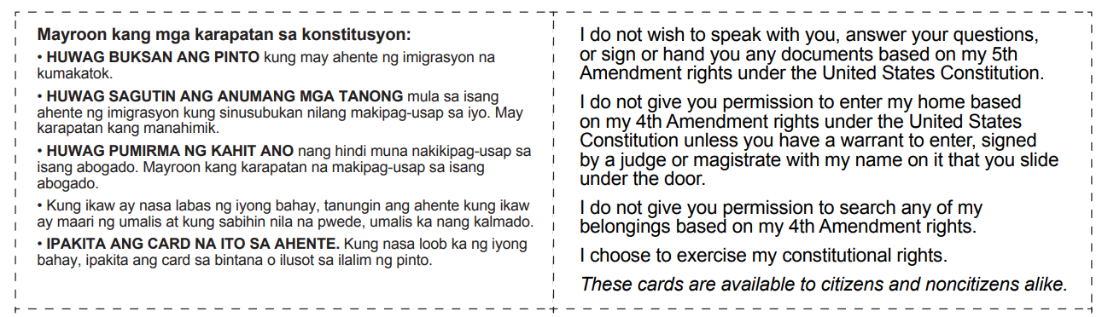
- For Cellphone Picture – Know Your Constitutional Rights Card – Tagalog Version

- For Cellphone Picture – Know Your Constitutional Rights Card – Tigrinya Version
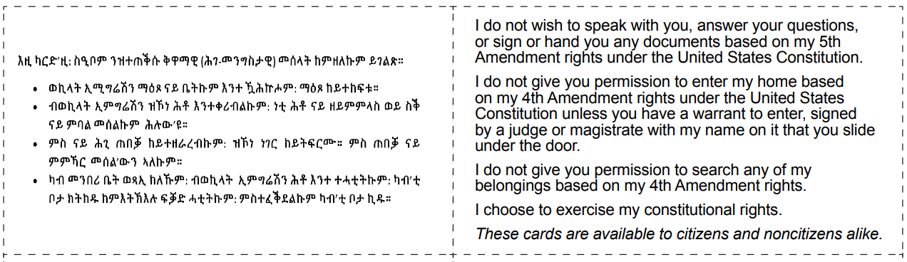
- For Cellphone Picture – Know Your Constitutional Rights Card – Ukrainian Version


