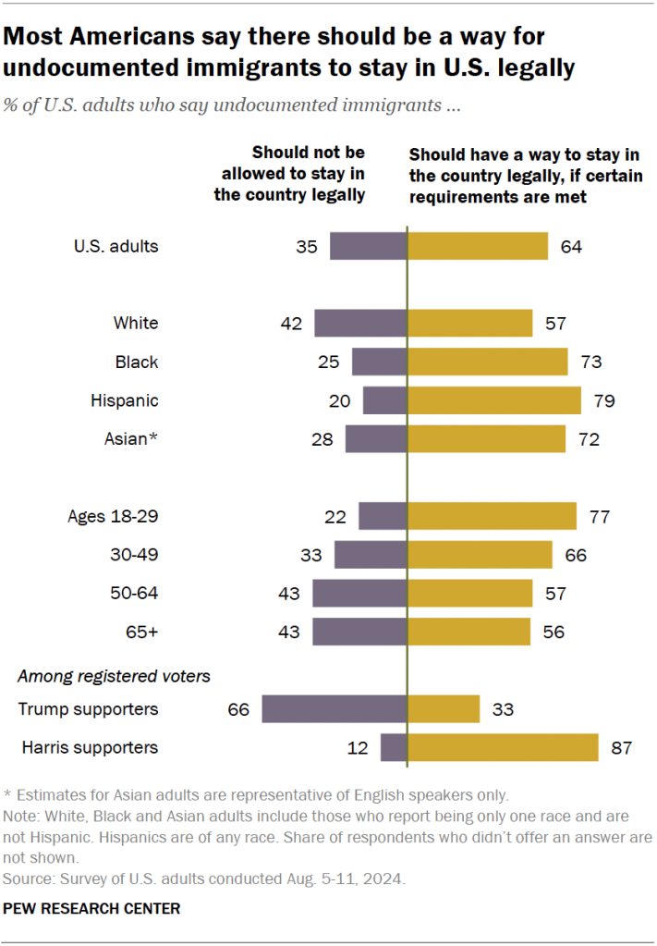
Please take a moment to review these two graphs depicting a Pew Research Center’s 2024 survey and see that 64% of Americans want a way that allows undocumented immigrants to stay in the U.S. legally!
https://www.pewresearch.org/short-reads/2024/11/22/most-americans-say-undocumented-immigrants-should-be-able-to-stay-legally-under-certain-conditions/

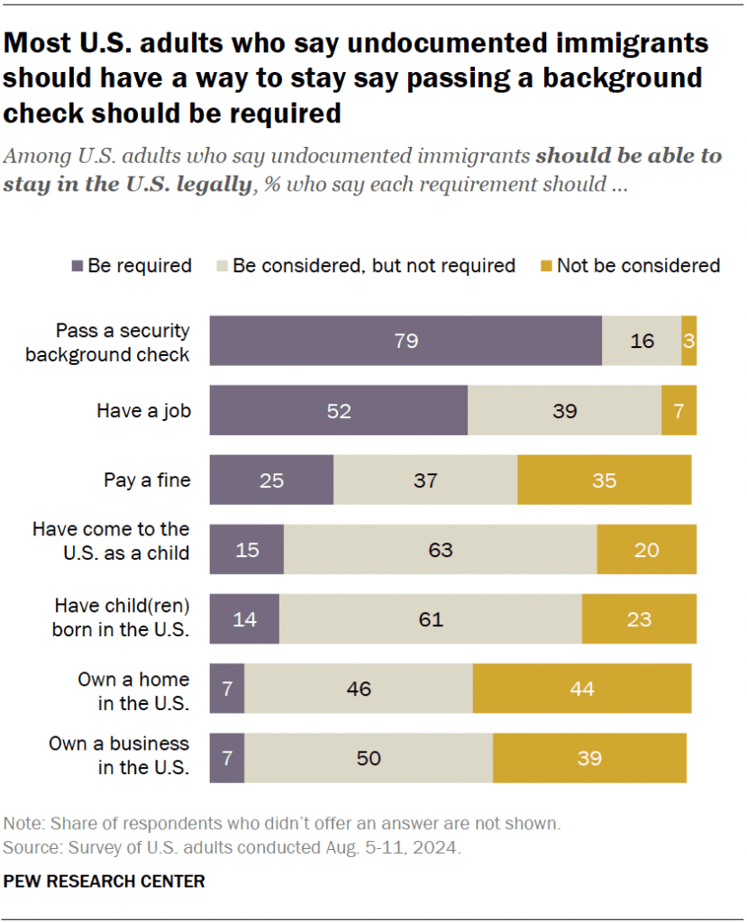
Next page
Recommended naming convention for immigrant groups
and
Office of Homeland Security (OHS) glossary
of terms

Most printed materials, like the NY Immigration Coalition’s handouts, generally use the generic term “immigrants” in a document. If a non-federal organization, like a newspaper or research group, publishes an article on immigrants and wants to breakout the “unauthorized” immigrants (federal terminology) group, they usually use the term “undocumented” immigrants in their publication.
I am recommending that our group uses the term “immigrant” whenever possible unless we want to specifically identify a subgroup of immigrants. Here is a way to identify specific subgroups of immigrants:
- “Undocumented Immigrant” will be used to identify the 11 million undocumented / unauthorized / illegal / non-citizen immigrants currently living in the U.S.
Note: Immigrants in the Deferred Action for Childhood Arrivals (DACA) program “currently” have temporary protection from deportation, but they are still considered undocumented immigrants. Note: an immigrant’s DACA status must be renewed every two years or they will lose it. The renewal fee is $495.
- “Legal Immigrant” will be used to identify the 36.8 million immigrants who are naturalized U.S. citizens (63%), lawful permanent residents (31% - Green Card holders who are allowed to live and work permanently in the U.S.), and lawful temporary residents (5% - students with an F1 visa) currently living in the U.S.
- “Asylum Seeker” will be used to identify refugees who are trying to enter the U.S. legally at a port of entry or illegally along the U.S. border, and do not currently live in the United States.

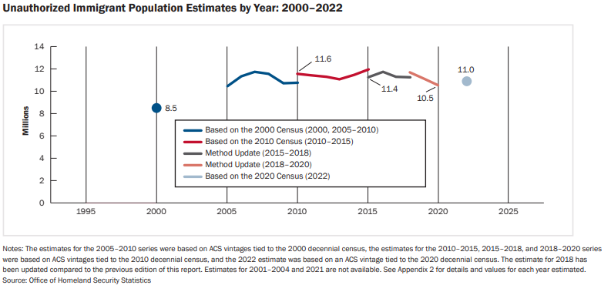
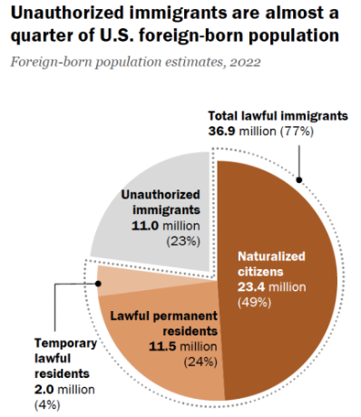

https://www.pewresearch.org/short-reads/2024/07/22/what-we-know-about-unauthorized-immigrants-living-in-the-us/
https://ohss.dhs.gov/sites/default/files/2024-06/2024_0418_ohss_estimates-of-the-unauthorized-immigrant-population-residing-in-the-united-states-january-2018%25E2%2580%2593january-2022.pdf

Finally, the remaining nine pages of this document provide:
- The Office of Homeland Security Statistics’ (OHSS) detailed definition of “Legal Resident” and “Unauthorized Immigrants” used in OHSS report, and
- A “searchable” glossary of terms used by OHSS.
The provided glossary of terms only contains “selected” OHSS terms which I thought might be the most relevant to the work we are doing.
--------------------------------------------------------------------------------------------------------------------------------------------------------------------
“Estimates of the Unauthorized Immigrant Population Residing in the United States: January 2018–January 2022” Office of Homeland Security Statistics’ (OHSS) Report, April 2024
Here are OHSS’s definition on “Legal Resident” and “Unauthorized Immigrants” used in the above report.
Legal Residents The legally-resident, foreign-born population, as defined for these estimates, includes naturalized citizens, children who derived citizenship from one or more parents, persons granted lawful permanent residence, persons granted asylum, persons admitted as refugees, and persons admitted as resident nonimmigrants (i.e., students and temporary workers, as opposed to tourists) who have unexpired authorized periods of admission.
Unauthorized Immigrants The resident unauthorized immigrant population is defined as all foreign-born noncitizens who are not legal residents as defined above. Most unauthorized immigrants either entered the United States without inspection or were admitted temporarily and remained past the date they were required to depart. Persons who are beneficiaries of Temporary Protected Status (TPS), Deferred Action for Childhood Arrivals (DACA) or other forms of prosecutorial discretion, or who are residing in the United States while awaiting removal proceedings in immigration court are included among the estimates of the unauthorized population. Unauthorized immigrants applying for adjustment to LPR status under the Immigration and Nationality Act (INA) are considered to be part of the resident unauthorized population until they have been granted lawful permanent residence. Individuals who were paroled into the United States are considered to be unauthorized immigrants until they are admitted or otherwise acquire immigration status.
https://ohss.dhs.gov/topics/immigration/unauthorized-immigrants/estimates-unauthorized-immigrant-population-residing


GLOSSARY

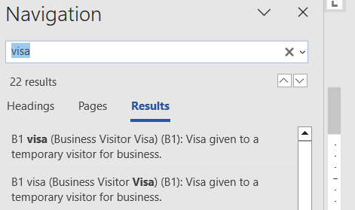
Source of glossary: https://ohss.dhs.gov/glossary
If this document is opened up in a Microsoft Word program, you can search for a specific word or phrase in the below glossary by simply pressing the “Control” and “F” keys, then use the displayed Navigation box to find every instance where this specific word or phrase was mentioned in this condensed version of the OHSS’s Glossary.

Arrest: Act of detaining an individual by legal authority based on an alleged violation of the law.
Arrest, administrative (administrative arrest): Detaining by Immigration and Customs Enforcement (ICE) within the interior of the United States of a noncitizen unlawfully present in the United States or of a lawfully present noncitizens who is subject to removal.
Arrest, criminal (criminal arrest): Detaining of an individual based on an alleged criminal offense, which may or may not have a nexus to immigration.
Asylee: Person granted asylum under section 208 of the Immigration and Nationality Act (INA).
Asylum: Form of protection provided to noncitizens physically present in the United States who meet the definition of refugee under Immigration and Nationality (INA) section 101(a)(42) and are not otherwise barred from applying for or receiving asylum.
Asylum, affirmative (affirmative asylum): Process through which a noncitizen who is physically in the United States and not currently in removal proceedings applies for asylum through U.S. Citizenship and Immigration Services (USCIS).
Asylum, defensive (defensive asylum): Process through which a noncitizen in removal proceedings applies for asylum with an Immigration Judge in immigration court as a defense against removal from the United States.
B1 visa (Business Visitor Visa) (B1): Visa given to a temporary visitor for business.
B2 visa (Tourist Visitor Visa) (B2): Visa given to a temporary visitor for pleasure.
Border Crossing Card (Border Crossing Identification Card) (BCC): A document of identity valid for 10 years and containing machine-readable fingerprint and other biometric data that is issued to certain noncitizens for the purpose of crossing over the borders between the United States and foreign contiguous territory in accordance with certain conditions and prescribed regulations.
Business nonimmigrant: A foreign national coming temporarily to the United States to engage in commercial transactions which do not involve gainful employment in the United States (i.e., engaged in international commerce on behalf of a foreign firm, not employed in the U.S. labor market, receives no salary from U.S. sources).
CBP One registration: The successful submission of a non-citizen's required information through CBP One App, including name, date of birth, photo, etc., Once a registration is complete, noncitizens are eligible to request an appointment to be processed at a Southwest border port of entry.
CBP removal: Any removal completed by CBP.
CBP return: Estimated movement by CBP of an inadmissible or deportable noncitizen out of the United States not based on an order of removal, including through voluntary departure, voluntary return, or withdrawal of application for admission.
Criminality: The deportation, exclusion, or removal of a noncitizen who has 1) been charged under a section of the Immigration and Nationality Act (INA) that requires a criminal conviction and that charge is the basis for the removal or 2) a criminal conviction noted in the Department of Homeland Security (DHS) immigration enforcement data systems for a crime that renders the noncitizen removable. A noncitizen with an appropriate criminal conviction is considered a criminal noncitizen regardless of the section of law under which the noncitizen was removed.
Criminal removal: A removal of a noncitizen with a known previous criminal conviction in the United States.
Custody (CBP): Noncitizens apprehended by the U.S. Customs and Border Protection (CBP) and detained in CBP short-term custody facilities or processing centers (up to 72 hours) for purposes of case processing and disposition, pending transfer to another agency, release, or additional or other actions.
Custody (ICE): Noncitizens detained in Immigration and Customs Enforcement (ICE) civil immigration detention system in furtherance of their removal proceedings or to affect their departure from the United States after a final order of removal from a federal immigration judge.
DHS administrative return: A return completed by OFO that results from an administrative encounter; OFO is the only DHS component that completes administrative returns.
DHS administrative return type: Administrative return types include crew members denied landing rights or detained on board their vessels and certain withdrawal of application for admission prior to 2024.
DHS enforcement return: Any return completed by ICE, CBP, or OFO that results from an enforcement encounter.
DHS enforcement return type: Return types include voluntary returns, voluntary departures, withdrawal of application for admission, and crew members denied landing rights or detained on board their vessels.
DHS removal: Any removal completed by OFO, USBP, or ERO.
DHS removal type: Removals include the confirmed movement of an inadmissible or deportable noncitizen out of the United States by Immigration and Customs Enforcement (ICE) Enforcement and Removal Operations (ERO) based on a final order of removal or the removal of an inadmissible or deportable noncitizen out of the United States by Customs and Border Protection (CBP). Removal types include expedited removal, reinstatement of a previous removal order, and administrative removal.
DHS repatriation: Any departure of an excludable, inadmissible, or removable noncitizen out of the United States based on (1) the compulsory execution of an order of removal against the person under Title 8 authority, (2) a return under Title 8 authority that is not pursuant to an order of removal, or (3) an expulsion from the United States to prevent the spread of the COVID-19 disease pursuant to Title 42 authority.
DHS return: The confirmed movement of an inadmissible or removable noncitizen out of the United States by Immigration and Customs Enforcement (ICE) Enforcement and Removal Operations (ERO) or Customs and Border Protection (CBP) not based on a final order of removal.
DHS transfers to HHS: Unaccompanied children encountered by Customs and Border Protection (CBP) and transferred to the care and custody of the Department of Health and Human Services (HHS).
Diversity immigrants: Category of persons who obtained Lawful Permanent Resident (LPR) status through the Diversity Immigrant Visa Program, designed to allow immigration from countries with low rates of immigration to the United States, as defined by the Immigration and Nationality Act.
Immigrant: Any person lawfully in the United States who is not a U.S. citizen, U.S. national, or person admitted under a nonimmigrant category as defined by the Immigration and Nationality Act (INA) section 101(a)(15).
Immigrant visa: A visa issued by a consular officer outside of the United States to a person eligible to immigrate to the United States to become a lawful permanent resident.
Inadmissible noncitizen: Foreign national who has not been inspected and admitted to the United States who is subject to the grounds of removal specified in section 212 of the Immigration and Nationality Act (INA).
Lawful Permanent Resident (LPR): Status accorded to an individual who has been lawfully accorded the privilege of residing permanently in the United States as an immigrant in accordance with immigration laws, such status not having changed.
Expedited removal (ER): An administrative procedure described in INA § 235(b)(1) that allows DHS officials to remove certain noncitizens who have entered without inspection or who have committed misrepresentation or fraud without a hearing before an immigration judge. Persons being processed for ER who claim a fear of return to their country of removal are referred to a USCIS fear screening, and if their fear claim is found credible (positive fear determination) they are placed in INA § 240 proceedings before an immigration judge.
Expulsion: Noncitizen expelled under Title 42 authority to their country of last transit or, if a person cannot be returned to the country of last transit, to their country of origin.
Green Card: Document also known as a Permanent Resident Card, Form I-551, and issued by U.S. Citizenship and Immigration Services (USCIS) to noncitizens as evidence of their lawful permanent resident (LPR) status in the United States.
H-1B petition: An application form used by employers seeking permission for a foreign national to work temporarily in the United States. An H-1B petition must be approved by the Department of Homeland Security (DHS) before a foreign national specialty worker, whether residing overseas or within the United States at the time of application, is authorized to begin or continue working in the United States.
I-134 beneficiary: An individual that receives a benefit. In case of I-134/A, the individual submitting the I-134 is the supporter, as they are submitting the I-134 to financially support a specified beneficiary during their time in the United States. The individual being supported is the beneficiary.
ICE ERO administrative arrest: The physical apprehension of a noncitizen by an Immigration and Customs Enforcement (ICE) Enforcement and Removal Operations (ERO) officer. ICE administrative arrests do not always lead to the noncitizen being detained in ICE custody.
ICE ERO area of responsibility (AOR): Any one of 25 geographical areas (plus Headquarters) in the United States associated with a U.S. Immigration and Customs Enforcement's (ICE) Enforcement and Removal Operations (ERO) field office within which the field office has the authority to plan and conduct immigration enforcement and removal operations.
ICE removal: Any removal completed by ICE. Note that ICE's public reporting on removals completed by ICE also includes ICE returns.
ICE return: Any return completed by ICE. Note that ICE includes returns in its reporting on ICE removals.
Immigrant: Any person lawfully in the United States who is not a U.S. citizen, U.S. national, or person admitted under a nonimmigrant category as defined by the Immigration and Nationality Act (INA) section 101(a)(15).
Immigrant visa: A visa issued by a consular officer outside of the United States to a person eligible to immigrate to the United States to become a lawful permanent resident.
Lawful Permanent Resident (LPR): Status accorded to an individual who has been lawfully accorded the privilege of residing permanently in the United States as an immigrant in accordance with immigration laws, such status not having changed.
Migrant: A person who leaves his/her country of origin to seek temporary or permanent residence in another country
N-400 naturalization: The conferring of citizenship upon a person after birth through approval by U.S. Citizenship and Immigration Services (USCIS) of the person's naturalization application (USCIS Form N-400).
Naturalization: The conferring by any means of citizenship upon a person after birth.
New arrival (LPR): A foreign national living abroad who becomes a Lawful Permanent Resident (LPR) concurrently with admission to the United States at a U.S. port of entry after receiving an immigrant visa from U.S. Department of State (DOS).
Nonimmigrant: Any person in the United States not a U.S. citizen or U.S. national who is admitted on a temporary basis to the United States for a specific purpose under a nonimmigrant category as defined by the Immigration and Nationality Act (INA) section 101(a)(15).
Nonimmigrant admission, I-94 (I-94 (nonimmigrant) admission): Lawful entry into the United States of a foreign national under a nonimmigrant class of admission who is required to complete or obtain Department of Homeland Security (DHS) Form I-94 or I-94W.
Nonimmigrant visa: A visa properly issued to a person eligible to be admitted as a nonimmigrant to the United States.
Northern Central America or Northern Triangle countries (NCA): El Salvador, Guatemala, and Honduras.
Occupation (immigration): For a noncitizen entering the United States or adjusting immigration status without a labor certification, occupation refers to the employment held in the country of last lawful residence or in the United States. For a noncitizen entering the United States or adjusting immigration status with a labor certification, occupation is the employment for which certification has been issued.
OFO field office: Any one of 21 geographic areas into which the United States, including Customs and Border Protection (CBP) preclearance activities abroad, is divided for Office of Field Operations (OFO) activities.
OFO inadmissible: Determination that a person seeking admission at a port of entry (land, sea, or air) is ineligible to enter the United States.
Orphan (immigration): For immigration purposes, a child whose parents have died or disappeared, or who has been abandoned or otherwise separated from both parents. An orphan may also be a child whose sole or surviving parent is incapable of providing that child with proper care and who has, in writing, irrevocably released the child for emigration and adoption. In order to qualify as an immediate relative, the orphan must be under the age of sixteen at the time a petition is filed on his or her behalf. To enter the United States, an orphan must have been adopted abroad by a U.S. citizen (and spouse, if married) or be coming to the United States for adoption by a citizen.
Parole, advance (advance parole): Parole authorized in advance of an inadmissible noncitizen's arrival or for foreign nationals residing in the United States in other than lawful permanent resident status who need to travel and return and whose conditions of stay do not otherwise allow for readmission to the United States if they depart.
Parole (CBP): Discretionary permission granted to an otherwise inadmissible noncitizen to temporarily enter the United States due to an emergency and urgent humanitarian reason or significant public benefit.
Parolee: A noncitizen, appearing to be inadmissible to the inspecting officer, allowed into the United States for urgent humanitarian reasons or when that noncitizen's entry is determined to be for significant public benefit. Parole does not constitute a formal admission to the United States and confers temporary status only, requiring parolees to leave when the conditions supporting their parole cease to exist.
Parole, humanitarian (humanitarian parole): Parole authorized for "urgent humanitarian reasons" as specified by law, regulation, or declaration by the U.S. government.
Parole, I-94/ATD (I-94 parole-ATD): Noncitizens paroled into the United States by Customs and Border Patrol (CBP) and enrolled in an Immigration and Customs Enforcement (ICE) alternatives to detention (ATD) program prior to their release.
Parole (ICE): Temporary status granted to a noncitizen for release from Immigration and Customs Enforcement (ICE) custody due to humanitarian reasons or significant public benefit or because the noncitizen has made a claim for asylum and has been found to have a credible fear of persecution or torture if returned to his/her country of origin.
Parole in place (USCIS): Parole in place allows a noncitizen, who came into the United States without authorization by an immigration officer, to stay for a certain period of time and is granted on a case-by-case basis for humanitarian reasons or significant public benefit.
Parole, overseas (overseas parole): Parole authorized by Department of Homeland Security (DHS) while the noncitizen is still overseas; designed to constitute long-term admission to the United States. In recent years, most of the noncitizens the Department of Homeland Security (DHS) has processed through overseas parole have arrived under special legislation or international migration agreements.
Parole, port-of-entry (port-of-entry parole): Parole authorized at the port upon noncitizen's arrival; used at the discretion of the supervisory immigration inspector, usually to allow short periods of entry, and applies to a wide variety of situations, such as allowing noncitizens who could not be issued the necessary documentation within the required time period, or who were otherwise inadmissible, to attend a funeral and permitting the entry of emergency workers, such as fire fighters, to assist with an emergency.
Parole, public interest (public interest parole): Parole authorized at Department of Homeland Security (DHS) headquarters for "significant public benefit" specified in the law; generally used for noncitizens who enter to take part in legal proceedings.
Per-country limit: The maximum number of family-sponsored and employment-based preference visas that can be issued to citizens of any country in a fiscal year.
Petitioner application confirmed: Confirmed filers of I-134A online requests to be a supporter and declaration of financial support for sponsors of individuals under the Family Reunification Parole Process.
Port of entry (POE): Any location in the United States or its territories that is designated as a port of entry (POE) for noncitizens and U.S. citizens.
Preference system (Immigration Act of 1990): The nine categories since fiscal year 1992 among which the family-sponsored and employment-based immigrant preference visas are distributed.
Priority 1 (P-1) refugee: Individuals referred by the United Nations High Commission on Refugees (UNHCR), a U.S. Embassy, or certain non-governmental organizations (NGOs) for refugee resettlement consideration.
Priority 2 (P-2) refugee: Groups of special humanitarian concern for refugee resettlement consideration.
Priority 3 (P-3) refugee: Family reunification cases for refugee resettlement consideration.
Reasonable fear: A “reasonable possibility” an individual would be persecuted or subject to torture in the future on account of their race, religion, nationality, membership in a particular social group, or political opinion if returned to their country of origin. The reasonable fear screening process is triggered when an individual subject to final administrative removal or reinstatement of removal expresses to an Immigration and Customs Enforcement (ICE) or Customs and Border Patrol (CBP) officer a fear of returning to the country to which they have been ordered removed.
Refugee: Status granted to an individual, prior to departure for and arrival in the United States, who has been determined by competent authority to be fleeing persecution or have a well-founded fear of persecution in their own country because of race, religion, nationality, membership in a particular social group or political opinion.
Refugee approvals: The number of refugees approved for admission to the United States during a fiscal year by Department of Homeland Security (DHS) officers in overseas offices.
Refugee authorized admissions: The maximum number of refugees allowed to enter the United States in a given fiscal year. As set forth in the Refugee Act of 1980 (Public Law 96-212) the President determines the annual figure after appropriate consultation with Congress.
Refugee resettlement: Permanent relocation of refugees in a place outside their country of origin to allow them to establish residence and become productive members of society there. Refugee resettlement in the United States is accomplished with the direct assistance of private voluntary agencies working with the Department of Health and Human Services (HHS) Office of Refugee Resettlement (ORR).
Region: One of eight continental or subcontinental areas (excluding Antarctica) that includes multiple countries; regions are Africa, Asia, Caribbean, Central America, Europe, North America (including or excluding Caribbean and Central America), Oceania, and South America.
Removal: The compulsory and confirmed movement of an inadmissible or removable noncitizen out of the United States based on an order of removal. A noncitizen who is repatriated pursuant to a removal order has administrative or criminal consequences placed on subsequent reentry owing to the fact of the removal.
Repeat encounter (CBP): Refers to a noncitizen encountered by Customs and Border Patrol (CBP) more than once within the previous 12 months.
Return: Confirmed movement of an inadmissible or removable noncitizen out of the United States not based on an order of removal. Returns include voluntary departures, voluntary returns, withdrawals of applications for admission, and crew members without entry visas who are required to remain aboard their ships.
Sex: Biological forms described as male or female. Unknown sex indicates instances where sex cannot be determined or was not recorded.
Single adults (SA): A noncitizen encountered by Customs and Border Protection (CBP) who is at least 18 years of age and not part of a family unit.
Single minors: Individuals under 18 encountered without an adult family member who were encountered and expelled under Title 42 authority.
Special immigrant (SI): Certain categories of Legal Permanent Residents (LPR) who were exempt from numerical limitation before fiscal year 1992 and subject to limitation under the employment-based fourth preference beginning in 1992.
Special Immigrant Visa (SIV): A visa properly issued by a consular officer outside of the United States to a person eligible to immigrate to the United States to become a lawful permanent resident under a special immigrant class of admission (COA).
Student (nonimmigrant): A foreign national coming temporarily to the United States to pursue a full course of study in an approved program in either an academic (college, university, seminary, conservatory, academic high school, elementary school, other institution, or language training program) or a vocational or other recognized nonacademic institution.
Subject to the numerical limit (immigration): Categories of lawful immigrants subject to annual limits under the provisions of the flexible numerical limit of 675,000 set by the Immigration Act of 1990.
Temporary Protected Status (TPS): Temporary Protected Status (TPS) allows certain eligible nationals of a foreign state to apply for temporary refuge in the United States after a finding that conditions in that country pose a danger to personal safety due to ongoing armed conflict or an environmental disaster.
Temporary visitor for business: A foreign national coming temporarily to the United States to engage in commercial transactions which do not involve gainful employment in the United States, (i.e., engaged in international commerce on behalf of a foreign firm, not employed in the U.S. labor market, and receives no salary from U.S. sources).
Temporary visitor for pleasure: A foreign national coming temporarily to the United States for tourism or other non-business purposes.
Temporary worker: A foreign national coming to the United States to work for a temporary period of time.
Title 42 (T42): Title 42 of the United States Code, which includes provisions related to public health. Border encounters processed under a March 2020 Centers for Disease Control (CDC) order pursuant to Title 42 are expelled from the United States as expeditiously as possible in the interest of U.S. public health to prevent the spread of the COVID-19 disease.
Title 42 expulsion: U.S. Border Patrol (USBP) or Office of Field Operations (OFO) encounter expelled from the United States as expeditiously as possible in the interest of U.S. public health to prevent the spread of the COVID-19 disease pursuant to the March 2020 Centers for Disease Control (CDC) order under Title 42 authority. Title 42 expulsions occurred between March 20, 2020, and May 11, 2023.
Title 8 (T8): Title 8 of the United States Code, which includes most provisions for immigration enforcement. Encounters processed under Title 8 authority may be subject to removal from the United States.
Title 8 repatriations: The sum of Title 8 removals and Title 8 returns. This does not include noncitizens expelled pursuant to the Centers for Disease Control's (CDC) Title 42 order.
Temporary visitor for business: A foreign national coming temporarily to the United States to engage in commercial transactions which do not involve gainful employment in the United States, (i.e., engaged in international commerce on behalf of a foreign firm, not employed in the U.S. labor market, and receives no salary from U.S. sources).
Temporary visitor for pleasure: A foreign national coming temporarily to the United States for tourism or other non-business purposes.
Temporary worker: A foreign national coming to the United States to work for a temporary period of time.
Title 42 (T42): Title 42 of the United States Code, which includes provisions related to public health. Border encounters processed under a March 2020 Centers for Disease Control (CDC) order pursuant to Title 42 are expelled from the United States as expeditiously as possible in the interest of U.S. public health to prevent the spread of the COVID-19 disease.
Title 42 expulsion: U.S. Border Patrol (USBP) or Office of Field Operations (OFO) encounter expelled from the United States as expeditiously as possible in the interest of U.S. public health to prevent the spread of the COVID-19 disease pursuant to the March 2020 Centers for Disease Control (CDC) order under Title 42 authority. Title 42 expulsions occurred between March 20, 2020, and May 11, 2023.
Title 8 (T8): Title 8 of the United States Code, which includes most provisions for immigration enforcement. Encounters processed under Title 8 authority may be subject to removal from the United States.
Title 8 repatriations: The sum of Title 8 removals and Title 8 returns. This does not include noncitizens expelled pursuant to the Centers for Disease Control's (CDC) Title 42 order.
Type of admission (LPR): One of two paths to Lawful Permanent Resident (LPR) status, depending on whether a person applies for an immigrant visa abroad (New Arrival) or seeks LPR status from within the United States (Adjustment of Status).
Unaccompanied children (UC): Individuals younger than 18 years old encountered by Customs and Border Protection (CBP) under Title 8 authority who are determined to have no lawful immigration status and who either do not have a parent or legal guardian in the United States or do not have a parent or legal guardian in the United States who is available to provide care and physical custody.
Unauthorized immigrant population: The unauthorized immigrant population is defined as all foreign-born non-citizens who are not legal residents, including naturalized citizens, persons granted lawful permanent residence, persons granted asylum, persons admitted as refugees, and persons admitted as resident nonimmigrants (i.e., students and temporary workers, as opposed to tourists) who have unexpired authorized periods of admission. Most unauthorized immigrants either entered the United States without inspection or were admitted temporarily and remained past the date they were required to depart.
Visa Waiver Program (VWP): The VWP allows citizens of certain selected countries to travel temporarily to the United States under the nonimmigrant admission classes of visitors for pleasure and visitors for business, to enter the United States without obtaining nonimmigrant visas, and to be admitted for no more than 90 days.
Voluntary departure: The departure of a noncitizen from the United States without an order of removal and may or may not have been preceded by a hearing before an immigration judge. A noncitizen allowed to voluntarily depart concedes removability but does not have a bar to seeking admission at a POE at any time. Failure to depart within the time granted results in a fine and a 10-year bar to several forms of relief from deportation.
Years before naturalization: Number of whole years a person was in lawful permanent resident (LPR) status before naturalization.

