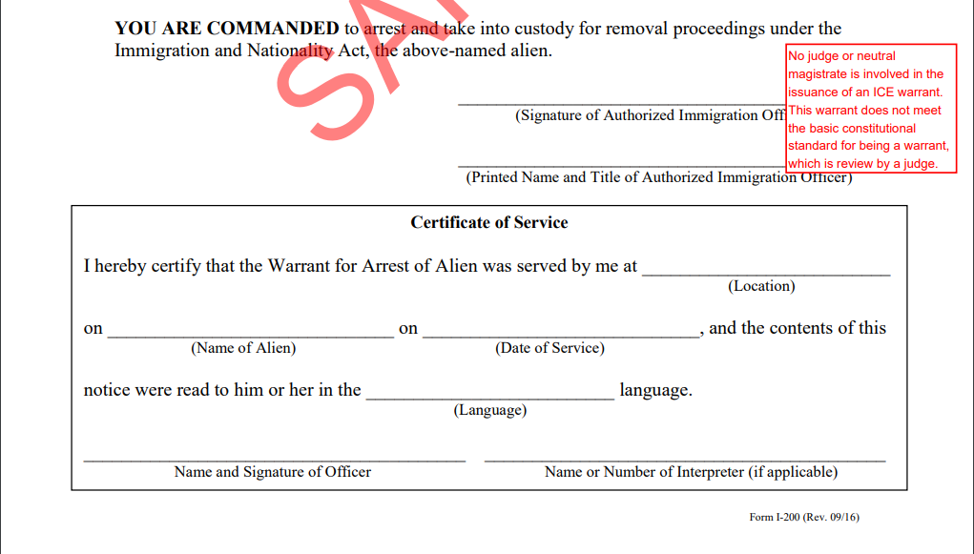
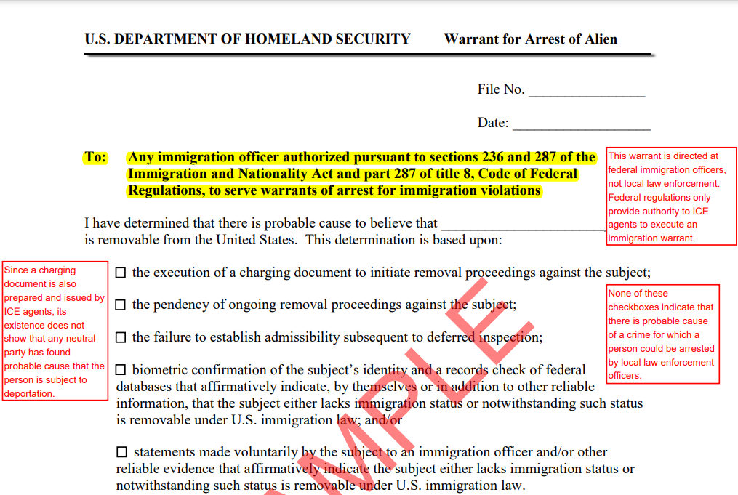

This form is signed by an immigration agent and not by a judge of magistrate...
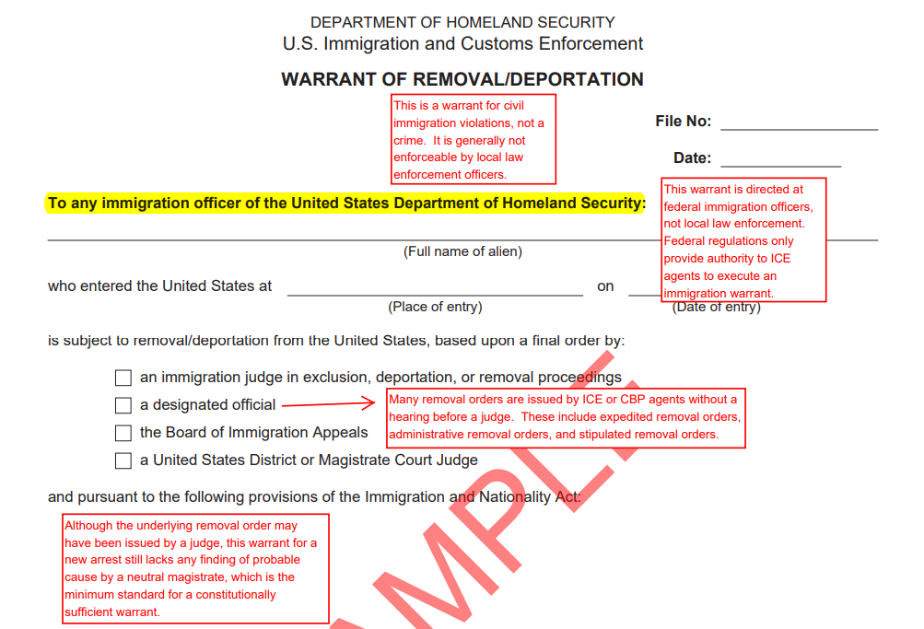
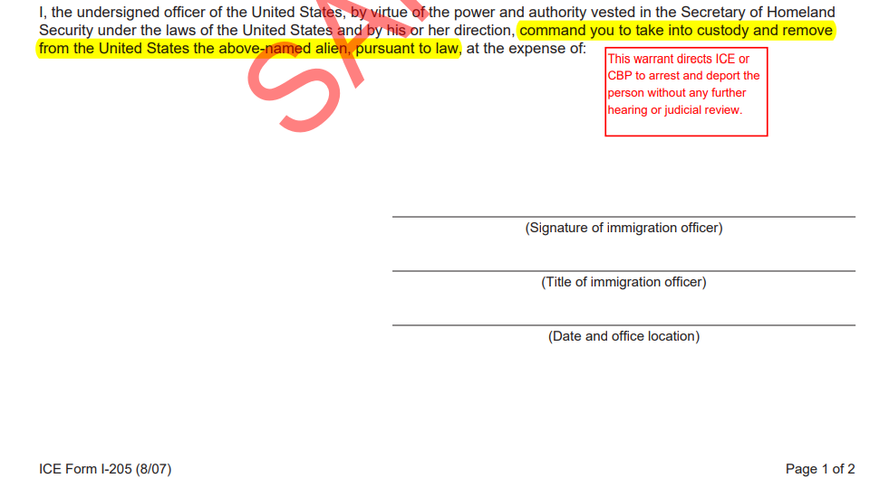
This form is signed by an immigration agent and not by a judge of magistrate...
Sample of second page not provided in this handout.

